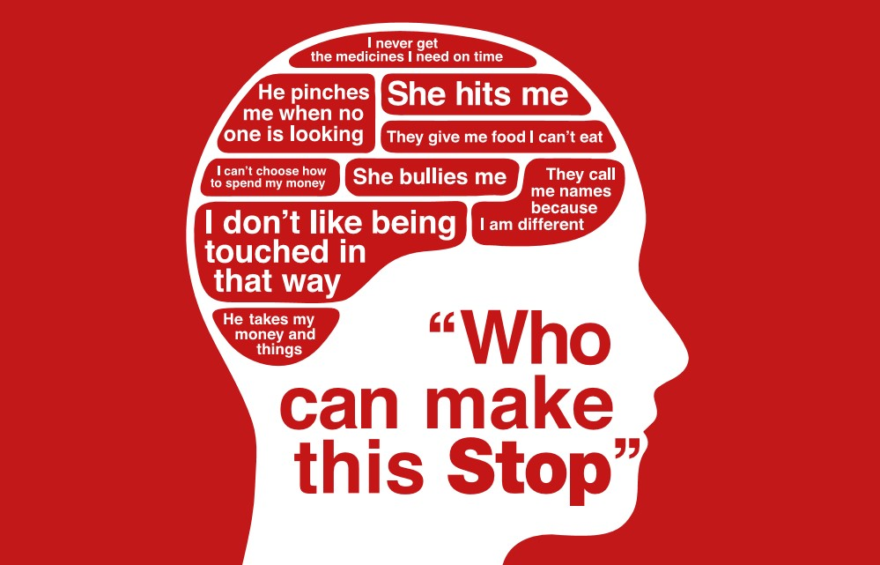

***If you are concerned or worried about yourself***

***or someone you know, please contact:***

* ***Adult Social Care: 01274 435400***
* ***Children’s Social Care: 01274 435600***

***You can also report a concern by logging on to the SaferBradford Website:***

[***https://www.saferbradford.co.uk/report-a-concern***](https://www.saferbradford.co.uk/report-a-concern)

***or scan the QR code***

* ***Adult Social Care: 01274 435400***
* ***Children’s Social Care: 01274 435600***

**Or follow this link:** [***https://www.saferbradford.co.uk/report-a-concern***](https://www.saferbradford.co.uk/report-a-concern)

* ***Adult Social Care: 01274 435400***
* ***Children’s Social Care: 01274 435600***

**Or follow this link:** [***https://www.saferbradford.co.uk/report-a-concern***](https://www.saferbradford.co.uk/report-a-concern)

* ***Adult Social Care: 01274 435400***
* ***Children’s Social Care: 01274 435600***

**Or follow this link:** [***https://www.saferbradford.co.uk/report-a-concern***](https://www.saferbradford.co.uk/report-a-concern)

* ***Adult Social Care: 01274 435400***
* ***Children’s Social Care: 01274 435600***

**Or follow this link:** [***https://www.saferbradford.co.uk/report-a-concern***](https://www.saferbradford.co.uk/report-a-concern)

* ***Adult Social Care: 01274 435400***
* ***Children’s Social Care: 01274 435600***

**Or follow this link:** [***https://www.saferbradford.co.uk/report-a-concern***](https://www.saferbradford.co.uk/report-a-concern)

* ***Adult Social Care: 01274 435400***
* ***Children’s Social Care: 01274 435600***

**Or follow this link:** [***https://www.saferbradford.co.uk/report-a-concern***](https://www.saferbradford.co.uk/report-a-concern)

* ***Adult Social Care: 01274 435400***
* ***Children’s Social Care: 01274 435600***

**Or follow this link:** [***https://www.saferbradford.co.uk/report-a-concern***](https://www.saferbradford.co.uk/report-a-concern)

* ***Adult Social Care: 01274 435400***
* ***Children’s Social Care: 01274 435600***

**Or follow this link:** [***https://www.saferbradford.co.uk/report-a-concern***](https://www.saferbradford.co.uk/report-a-concern)