Bradford Safeguarding Partnership Business Unit
BSAB@bradford.gov.uk

Organisational safeguarding self assessment Audit
Questions and Guidance Notes

Contents

Section | Page
Introduction | 3
Getting Started | 4
Using The Traffic Light System of Red, Amber or Green | 5
Following Submission | 6
Questions and Guidance
1. Senior management commitment to the importance of safeguarding and promoting adults at risk and/or children’s welfare. | 8
2. A clear statement of the organisation’s responsibilities towards children and/or adults at risk is available for staff and volunteers | 8
3. A clear line of accountability exists within the organisation for work on the safeguarding of children | 10
4. Developments within the organisation take account of the need to safeguard children and adults at risk, and is informed, where appropriate, by their views and that of their families | 11
5. Training on safeguarding children/adults at risk for staff and volunteers working with, or in contact with children and families | 12
6. Safer recruitment | 14
7. Effective inter-agency working to safeguard children / adults | 15
8. Staff are aware of the information sharing procedure for their organisation | 16
9. Work with individual children, adults at risk and their families/carers | 16

Introduction
Section 11 of the 2004 Children Act sets out the provision for Safeguarding Children Partnerships to undertake a self-assessment audit of how organisations and services are meeting standards to safeguard children and young people. The Safeguarding Adult Audit has been developed through sector-led improvement in Yorkshire and Humber.
This year a working group from across Yorkshire and Humber – led by Leeds Safeguarding Partnership have created a combined Childrens and Adults online audit tool.
The tool has been developed to assess how organisations and services in Bradford are meeting standards to safeguard children and adults at risk.

The purpose of this annual exercise is to:
- Provide all organisations and groups that work with / are involved with children and adults with the opportunity to provide an account of how they prioritise safeguarding
- Provide evidence of how organisations or groups have been able to learn and improve in how they did this.

The role of BSAB / TBP is to support this exercise and to collate the responses in order that it may be determined:
- What the self-assessments tell us about the effectiveness of arrangements for the safeguarding of children and adults in Bradford
- What this tells us about the effectiveness of joint working to protect children and adults in Bradford

The Organisation Safeguarding Self-Assessment Audit is available to complete online: https://safeguardingorg.uk/

The audit is spilt into 9 Sections
Senior management commitment to the importance of safeguarding and promoting adults at risk and/or children’s welfare.
A clear statement of the organisation’s responsibilities towards children and/or adults at risk is available for staff and volunteers
A clear line of accountability exists within the organisation for work on the safeguarding of children
Developments within the organisation take account of the need to safeguard children and adults at risk, and is informed, where appropriate, by their views and that of their families
Training on safeguarding children/adults at risk for staff and volunteers working with, or in contact with children and families
Safer recruitment

Effective inter-agency working to safeguard children

Staff are aware of the information sharing procedure for their organisation

Work with individual children, adults at risk and their families/carers

Getting Started
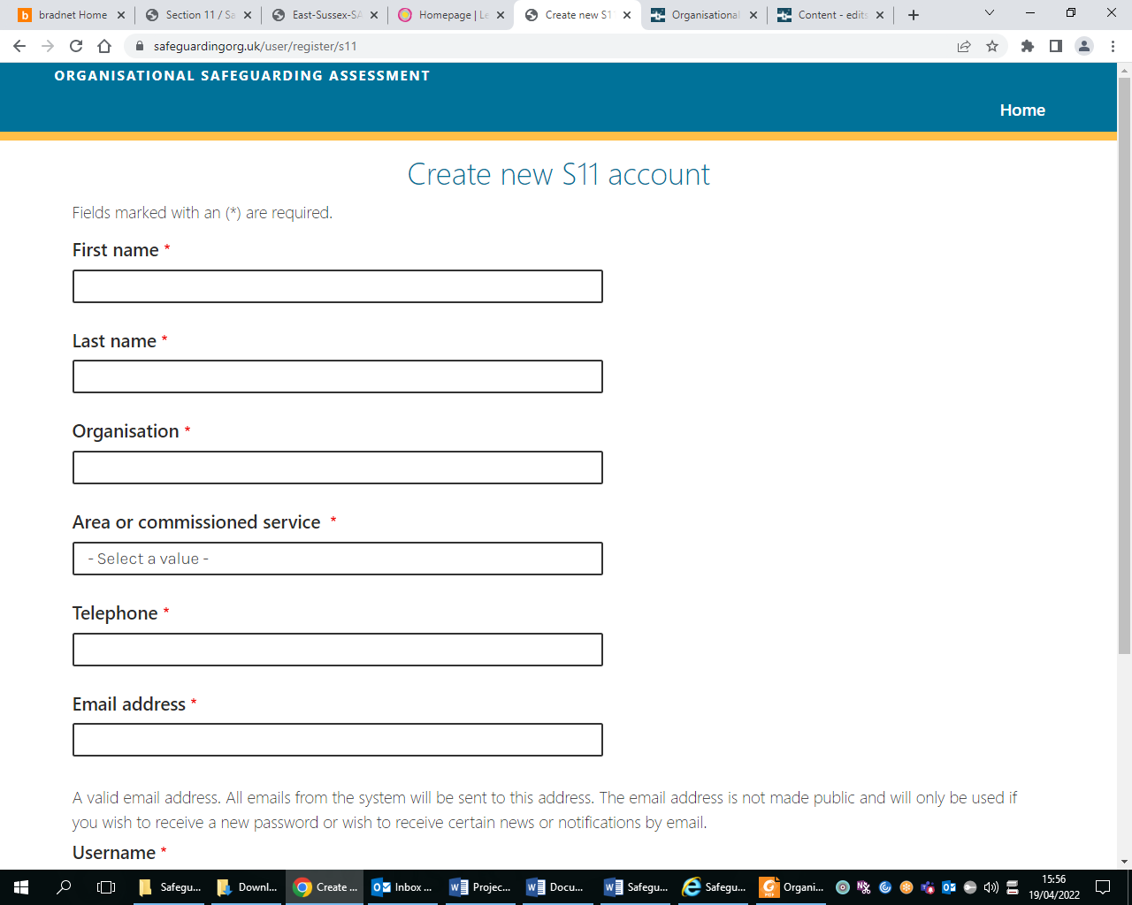
Please go to https://safeguardingorg.uk/
If you have not completed an OSA before
1. Click on ‘create new account’
2. Complete all the fields
3. Click ‘Create New Account’
4. An email will be sent to the email address
that you have used on the form. [Check your
email including your spam or junk email
folders.]
5. Copy and paste the link in the email into a
web browser
6. Choose a password (make sure the
password is in line with your organisations IT
policy)
7. Repeat the password
8. Click ‘Submit’ and then you are ready to
complete your first Organisational
Safeguarding Assessment form
If you have followed these instructions, checked your junk folder for auto response emails and still can’t log on, contact your local Safeguarding Partnership with the details of any error messages and a description of the issue.

- The ‘My Submissions’ page shows you the most recent version of the assessment you have worked on. If this is empty you have not yet filled out any part of your ‘Safeguarding form’ and therefore should do this first.
- When you click on ‘Safeguarding Form’ you will find all the questions that need completing for your safeguarding assessment.
- Fill out all the fields and then click ‘next’ to move onto the next set of questions.
- You can save the document as often as you like. There is an auto save function built in, but you will still need to ‘save draft’ as soon as possible and it will update your assessment even if you logged out by accident

Additional Support to Complete the Self-Assessment
If you have any questions regarding the self-assessment or would like support to complete the on line tool please email
(Children) TBPSafeguardingChildren@bradford.gov.uk
(Adults) BSAB@bradford.gov.uk

Using The Traffic Light System of Red, Amber or Green
For each section there is at least one question where organisations are asked to ‘RAG’ rate their organisations response.
Please answer all of the questions by selecting the most appropriate rating for your organisation
This document will provide organisations with guidance notes for each section
Red | Means that arrangements need to be developed as a matter of urgency
Amber | Means that some measures are in place but others require reviewing or improvement
Green | Means that the necessary arrangements are in place, up to date, and meet the required minimum standard.

When completing the audit, please indicate how the standards are applied by your organisation and state your reasoning for this. It is important to be objective and accurate to identify where your safeguarding arrangements can be improved.
If a question is not applicable to the work of your organisation, please select a GREEN rating and explain the reason for this not being applicable in the comments box.
Please note that you should answer all the questions prior to submission. If an Organisational Safeguarding Assessment has been submitted without all questions answered, unanswered questions will be allocated a RED rating.

Following Submission
Once you have completed all the questions and, submitted your assessment, you will be given the opportunity to:
- Download your submission
- Download and action plan
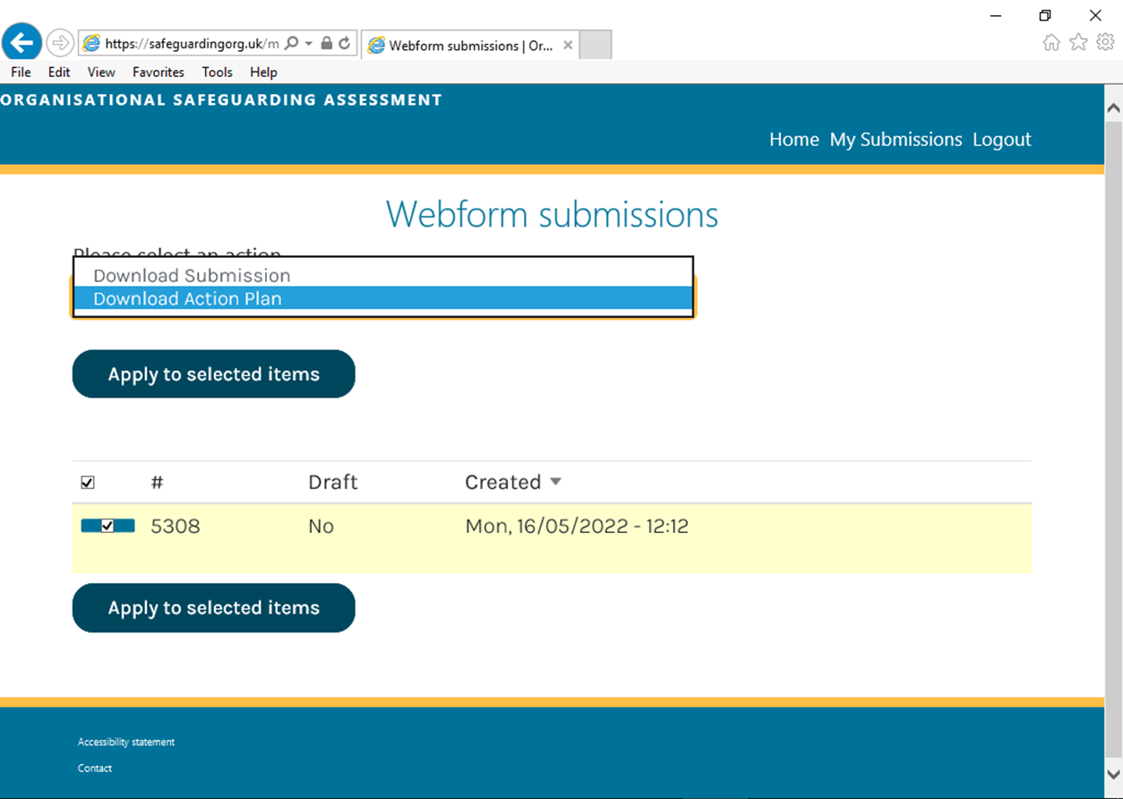
Your action plan will be similar to this:
Organisation: Bradford Safeguarding Adults Board |  | Completed by: Helen Khan |  | Date: 16/05/2022
Rating | Actions to be undertaken |  | Person responsible |  | By when | Progress made
1.1 Is there a person responsible for safeguarding at senior management level/trustee/or senior management committee?
red
1.2 Is there a system in place that demonstrates your commitment to safeguarding and which takes learning from reviews, audits and initiatives forward to enable improvements in practice?
amber | We have one named person but we need to sort out what to do when they are absent
2.1 Is an accessible safeguarding policy in place which sets out clearly the responsibilities of staff and volunteers for safeguarding children and/or adults at risk, including when and how to act on safeguarding concerns?
amber | The policy needs to be put on our website and staff need to know how to find it
2.2 Do staff and volunteers have access to all the organisation’s relevant policies and procedures, eg on the internet or in a staff handbook?
amber | The handbook needs to be made available on the intranet.
2.3 Do staff, including volunteers, have clearly identified responsibilities for safeguarding children and/or adults at risk?
amber | The learning module needs to be made available to volunteers

The ‘actions to be undertaken’ column will include the actions you have included when you were completing the assessment.
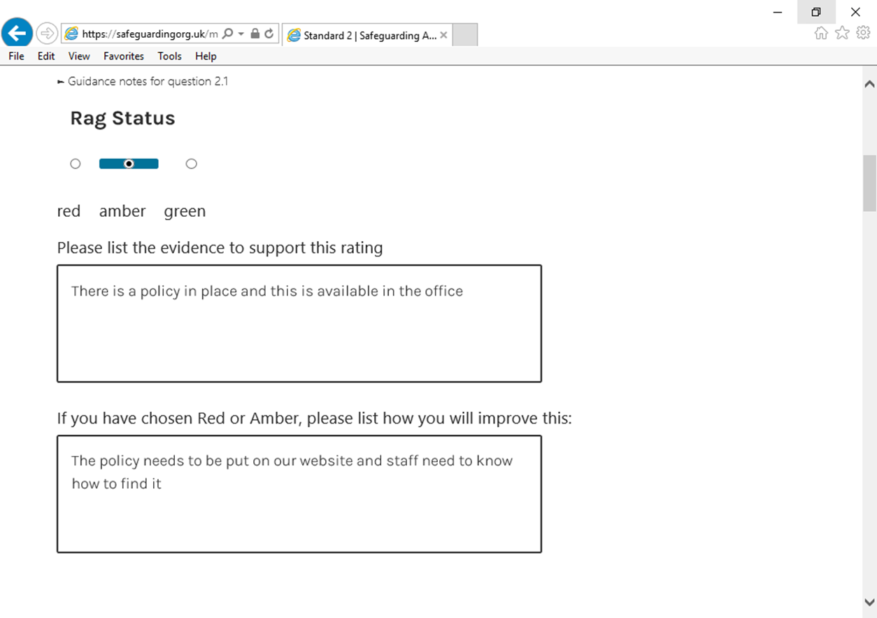

Questions and Guidance

1. Senior management commitment to the importance of safeguarding and promoting adults at risk and/or children’s welfare.

1.1 Is there a person responsible for safeguarding at senior management level/trustee/or senior management committee?
This means having a senior person to take forward safeguarding recommendations, new safeguarding initiatives or ways of working and to ensure safeguarding is taken seriously.
Senior managers, management committees or those in positions of responsibility need to show leadership, be informed about, and take responsibility for staff and volunteers who are providing services or working with children, their families or any adults at risk. This means having a named senior person to champion the importance of safeguarding children and adults at risk throughout the organisation. Senior managers, management committees or those in positions of responsibility are also responsible for making sure the behaviour of their staff safeguards children and vulnerable adults. This includes ensuring children, young people and adults at risk are listened to appropriately and concerns expressed about their welfare are taken seriously and responded to in an appropriate manner.

1.2 Is there a system in place that demonstrates your commitment to safeguarding and which takes learning from reviews, audits and initiatives forward to enable improvements in practice?
Are there meetings, groups or forums in the organisation which allow safeguarding concerns to be discussed and for staff and volunteers to be kept informed of any changes or recommendations for how they, or their organisation works? This could be changes in legislation from the Government, or recommendations from the Local Authority or the Safeguarding Children/Adults Partnership, e.g.; recommendations from Safeguarding Adult reviews, child safeguarding practice review or changes in training programmes or procedures etc.
This could also involve reviewing and updating your existing policies and procedures.

2.A clear statement of the organisation’s responsibilities towards children and/or adults at risk is available for staff and volunteers

2.1 Is an accessible safeguarding policy in place which sets out clearly the responsibilities of staff and volunteers for safeguarding children and/or adults at risk, including when and how to act on safeguarding concerns?
The organisation has policies and procedures that clearly identify staff roles regarding safeguarding children, young people and/or vulnerable adults.
This means staff and volunteers have clearly identified responsibilities for safeguarding children/vulnerable adults and this is included in induction and training sessions. Staff should be clear about their professional boundaries and when and where to pass on information. There should also be clear guidance on how identify neglect, harm and abuse and how to record and store information about safeguarding concerns and action taken. The organisation’s safeguarding policy and procedures should be easily accessible. These may link to policies about other issues such as confidentiality, bullying, health and safety, internet use, data protection and risk assessments.

2.2 Do staff and volunteers have access to all the organisation’s relevant policies and procedures, e.g. on the internet or in a staff handbook?
Do all staff and volunteers in your organisation know where to find and access to your safeguarding policies and procedures? e.g.; exploitation, missing and trafficking, modern day slavery etc.

2.3 Do staff, including volunteers, have clearly identified responsibilities for safeguarding children and/or adults at risk?

Are all of your staff and volunteers clear about their responsibilities to safeguarding and promoting the welfare of children and adults at risk? Is safeguarding including in job descriptions? All senior leaders and managers should ensure that all staff especially those involved in front line delivery, including subcontractors, are aware of the priority given to safeguarding and what to do if they are concerned about the safety and welfare of children or vulnerable adults.

2.4 Are staff informed of their professional boundaries and know when and where to pass on information?
Do all staff within your organisation understand the levels of appropriate interaction between themselves and the children, young people and adults that they work with? This includes both in and outside of the work place as well as contact through social media.
This should extend to any visitors, VIP's and visiting media to ensure that robust security and access arrangements are in place and what staff should do if there are any concerns.
It should be clear within your organisation with whom each staff member should discuss and whom and when they should report any concerns about a child’s or adults welfare.

2.5 Are effective complaints procedures in place for children, adults, staff, volunteers and other people where there are concerns that safeguarding has not been taken into account?
The organisation has effective complaints procedures for children, adults’ staff and other people when there are concerns that safeguarding has not been taken into account.
This means staff including volunteers are aware of how to make a complaint and of the correct procedure to follow. This includes how to escalate concerns if it is felt that decisions need to be reviewed. Policies must be available for staff and volunteers, and details should be given to anyone requesting them. They must be available for children and young people of all ages and adults at risks and presented in a way that that service users can understand.

2.6 Are there policies in place which include reference to the importance of listening to children and adults at risk and responding appropriately?
The organisation has policies that include the importance of listening to children/adults at risk and responding appropriately
This means consideration should be given to children and adults at risk whose first language is not English, and the organisation should take account of the Disability Act and any additional vulnerability or needs a child/adult may have. The organisation should always be person focused and ensure appropriate time and space is given to children and vulnerable service users

3. A clear line of accountability exists within the organisation for work on the safeguarding of children

3.1 Are safeguarding priorities contained in the organisation’s main or strategic plan/s?
The importance of safeguarding is reflected in the organisation’s main plan/s
This means safeguarding is taken account of within the organisation’s main or strategic plans and in all its activities, including the practice, training, recruitment and induction of staff and volunteers.

3.2 Does the organisation have policies and procedures that clearly show how to report welfare or safety concerns about children or adults at risk?
Policies and procedures are in place that clearly show how to report concerns about children/adults at risk and who this should be reported to.
This means staff and volunteers know when and who to report concerns to and how to escalate their concerns appropriately. This should be included in training and induction sessions. Procedures should be readily available for all staff and reviewed on a regular basis. It is good practice that these polices are available for service users.

3.3 Are safeguarding responsibilities included in job descriptions and or volunteer responsibilities?
Safeguarding responsibilities are identified in individual job descriptions
This question asks if safeguarding responsibilities are included in job descriptions and volunteer responsibilities and if staff and volunteers are fully aware to whom they are accountable.
Examples of good practice by organisations completing this include:
- Reviewing job description regularly
- Discussing safeguarding within supervision
- Basing Performance and Development Reviews on job description and ensuring safeguarding is included.
- Including Safeguarding questions at interview
- Including a statement around safeguarding as part of a job advert
- In respect of volunteers: organisations ensured safeguarding responsibilities were included in induction pack/role profile / handbook / volunteer agreement.
- Organisations also spoke of finding Safer Recruitment training helpful in writing job descriptions that ensure Safeguarding responsibilities are a priority.

3.4 If appropriate is safeguarding routinely discussed in supervision and included in staff appraisals?
Safeguarding is standing agenda item in supervision and is discussed if appropriate in staff appraisals.
This means that when staff receive supervision, safeguarding is discussed. This is essential for all staff who work with children, young people and their families or adults at risk. The organisation’s policy and guidance on safeguarding supervision for individual roles must be followed and the sessions must be recorded.

4.Developments within the organisation take account of the need to safeguard children and adults at risk, and is informed, where appropriate, by their views and that of their families

4.1 Does the development of new services or pieces of work take safeguarding children and/or adults at risk into account?
This means that when the organisation develops new services or pieces of work, they should consider how safeguarding will be taken into account. Children, young people, and adults at risk should be consulted in the development process to ensure that their needs are met.

4.2 Are the views of children, adults at risk, carers and families sought when the organisation is developing a new service or piece of work?
The views of children, adults at risk, carers and families have been sought regarding the development of services
This means that when a new piece of work is being considered, service users and families should be consulted regarding its development. The consultation process should include those with disabilities, specific needs as well as those from diverse cultural and ethnic backgrounds. The consultation notes should be recorded and made available within your organisation.
It Is recognised that organisations will differ with how much direct contact they have with children/adults at risk and how much their services directly impact on their users. Therefore, the expectation of the level of consultation with children/adults at risk will vary depending on the type of organisation.
Organisations with children in their care, e.g., children’s homes, fostering agencies, childcare and education settings should have:
- Regular children’s meetings
- Involve young people/adults at risk in recruitment
- Ensure close relationships with other professionals involved with children/adults at risk
- Regular one to one sessions with key workers
- Undertake questionnaires with children/adults at risk
- Hold feedback forums with children/adults at risk
Organisations working directly with children/adults at risk in the community could:
- Deliver surveys and questionnaires
- Hold consultations
- Deliver engagement activities
- Involve children/adults at risk in recruitment and training
- Develop an interactive website
- Involve children and adults at risk in the planning and delivery of events and activities
Organisations that don’t work directly with children/adults at risk could:
- Have regular consultation with service users – being aware that service users may be parents’/care givers.
- Use the Think Family, Work Family approach
- Consult with wider community using surveys, questionnaires, and forms.

4.3 Are services and new pieces of work developed to ensure equal access for all sectors of the community?
Services and new piece of work are developed which ensure equal access for all sectors of the target community.
When developing a new piece of work or service, do ensure that this service is accessible to all sectors of the community regardless of disability, needs or cultural backgrounds (where appropriate)? Can your service be easily and safely accessed by the children/vulnerable adults, carers and families for whom it is intended?

5.Training on safeguarding children/adults at risk for staff and volunteers working with, or in contact with children and families

5.1 Is the importance of safeguarding included in the organisation's induction programme for staff and volunteers?

Are all new staff and volunteers informed about their responsibility to safeguard and promote the welfare of children, young people and vulnerable adults in their induction programme?

5.2 Are the areas detailed in the guidance notes, covered within your organisation's safeguarding induction programme?
All staff and volunteers receive the training they need in order to safeguard children and young people effectively.
This means safeguarding is included in the organisation’s induction and training programme for staff and volunteers. Through training, all staff and volunteers should be aware of:
Their responsibilities regarding safeguarding of children and young people and adults at risk
Know how to spot abuse of neglect
The importance of listening to children and young people and adult at risk and how to facilitate this
Their professional boundaries, and when and how to share concerns about children and young people and/or adults
The role of the responsible person for safeguarding within the organisation
How to make or deal with a complaint about safeguarding
How to access the relevant policies and procedures
Take into consideration individual family circumstances

5.3 Do staff and volunteers attend in house introductory safeguarding training?

All staff are encouraged and given time from work to attend relevant safeguarding training, events, and workshops? Please refer to your Safeguarding Partnerships requirements.

5.4 Children services only: If the organisation provides its own introductory safeguarding training, does it meet the standards and requirements of the LSCP as outlined in The West Yorkshire LSCP Single Agency Introductory Safeguarding Training Self Audit Checklists?

This question is only applicable to those organisations that provide their own introductory safeguarding training. If your organisation does not provide this training then you can select Green as your response to this question and please explain that this question is not applicable to your organisation in the comments box.
Where your organisation does provide its own introductory safeguarding training, please state where it meets the standards as set out in the West Yorkshire LSCP Single Agency Introductory Safeguarding Training Self Audit Checklist, or the areas that you have identified which still need to be improved.
All safeguarding training should meet the West Yorkshire LSCP Single Agency Introductory Safeguarding Training Self Audit Checklist. The checklist can be found on our website in the training section.

5.5 Do you keep records of the safeguarding training attended by each volunteer or staff member?

Are personnel files kept up to date with training attendance records? Is this monitored by a senior member of staff who can identify where additional training is required?

5.6 Does your organisation ensure that staff are encouraged and required to attend child/adult protection and safeguarding training (as appropriate)?

Organisations should be able to clearly show commitment to safeguarding training. This means:
The organisation encourages and allows staff to attend child/adult protection/safeguarding training,
records who has attended safeguarding training, safeguarding is included in the organisation’s induction programme for staff and volunteers

5.7 Does the organisation have a compulsory safeguarding training programme for all levels of the organisation?
When new staff or volunteers are appointed, is safeguarding included in their induction training?

5.8 Does your organisation measure the impact of safeguarding training back in the workplace and on outcomes for children, young people and adults at risk?
In this question, impact refers to the change in practice e.g.; how has the training increased your ability to respond to any safeguarding concerns and how is the impact of training on staff performance assessed?
Your organisation can measure the impact of training in the following ways:
- Through supervision/appraisals;
- at team meetings;
- 6 months after the training has taken place, record the difference it has made to your practice within supervision/appraisal notes; and /or changes in the way you deliver your service.
- Suggestions of good practice include:
- Training is regularly discussed in staff supervision and learning from it recorded.
- Training and relevant learning is discussed within annual reviews/appraisals
- Training is discussed within staff meetings. Staff who have recently been on training should share their learning with the rest of the team.
- Staff asked to write a reflection on any training they attended and how it will impact their practice.
- All staff asked to regularly complete training records.

6.0 Safer recruitment

6.1 Does the organisation have a safer recruitment policy in line with your local Partnership procedures?

The organisation has a safer recruitment policy in line with the local Safeguarding Partnership arrangements.
This means that your organisation has recruitment policies for all staff and volunteers, paid or unpaid. These policies must be current, regularly reviewed and contain dates for reviewing DBS checks. Example contents may include verifying identity, scrutinising information provided by applicants, checking employment history, verifying qualifications, obtaining references and face to face interview process.

6.2 Have all DBS checks been carried out and updated in accordance with legal requirements?
Please see the Disclosure and Barring Service webpage for further information:
https://www.gov.uk/disclosure-barring-service-check/overview

6.3 Have people within the organisation who are involved in the recruitment and selection of staff attended safer recruitment training provided by the LSCP or attended an equivalent course?

Safer recruitment training has been provided for those involved in the recruitment and selection of staff
This means people in the organisation who are involved in the recruitment and selection of workers or volunteers have attended safer recruitment training provided by the Safeguarding Children/Adult Partnership or attended an equivalent course.
It is important to follow Safe Recruitment processes when hiring paid or unpaid staff, to prevent unsuitable people from working with children and young people in your organisation.

6.4 Does the organisation have procedures for workers to pass on concerns about staff and volunteers to managers, or an identified person in a position of responsibility who deals with, or responds to allegations made against staff?

The organisation has procedures in place for workers to pass on concerns about staff and volunteers to a manager, or a person in a position of responsibility who is identified to deal with allegations against staff or volunteers.
This means there is manager, or a person in a position of responsibility who is identified to deal with or respond to allegations made against staff or volunteers. Staff and volunteers should know who to pass their concerns to.

6.5 Children only: Is there a named senior officer/s or a person in a position of responsibility who ensure allegations are passed to the LADO (Local Authority Designated Officer)? For Adults: Does your organisation have effective working arrangements, consistent with the local safeguarding adults board, for responding to allegations against people in a position of trust?

For information on managing allegations against staff please see your local partnership arrangements.

6.6 Does the organisation ensure staff or volunteers are aware of the procedures for dealing with allegations made against staff?
Do your staff and volunteers know what the procedures are where a child/adult at risk has made an allegation against a member of staff, volunteer or a visitor/VIP who may be visiting? Are these procedures included in your safeguarding policy?

7. Effective inter-agency working to safeguard children / Adults

7.1 Is your organisation regularly represented within multi-agency safeguarding meetings and discussions?
There is a representative from the organisation who regularly attends safeguarding meetings or forums.
This means the organisation is represented at safeguarding meetings and, when appropriate, staff attend safeguarding meetings such Child Protection Conferences and other multi-agency meetings that support children or adults at risk. It is important that inter agency working should exist at both strategic and practice levels within your organisation.

7.2 Do staff and volunteers understand when to make a referral for a child or adult in need or at risk?
This means staff and volunteers understand the process and the level of seriousness needed for making a referral to Children Social Work Service/Adult Social Care Service and know the difference between a child/adult needing extra help and support, a child/adult welfare concern, a child/adult needing protection from abuse, and a child/adult protection concern.

7.3 Childrens Services only: If appropriate do staff know when to under-take or make a referral for an Early Help Assessment?
An early help assessment helps you to capture your assessment of the current needs of a child/young person and their family. It should be completed in partnership with the child/young person and their parents/carers. The assessment is used to agree next steps in order to access appropriate early help support and co-ordinate services. This is primarily intended to be used for a multi-agency assessment, however, could also be used for a single agency assessment. This should be kept on the child/young person’s file by the lead professional and also uploaded to Social Care database if you have appropriate access.
An Early Help Request form should be completed to make a request for early help support through and Early Help Hub or cluster, for a child/young person, or to refer a child or young person to an early help support service. See our Early Help pages for further information on the Early Help approach and contact details for early help support services. https://saferbradford.co.uk/resources/childrens/prevention-and-early-help/

8. Staff are aware of the information sharing procedure for their organisation

8.1 Do staff and volunteers understand when and how to share information if they have concerns that a child or adult at risk may be being abused or needs additional services?
Staff and volunteers in the organisation know what to do in terms of information sharing if they believe a child/adult at risk is in need of help and additional services
This means the organisation has clear procedures for staff and volunteers on how, when and what information to share. Care needs to be taken in sharing information from 3rd parties, as per example outlined in the Inter-agency Protocol for Sharing Information Agreement.
Further information is available here:
(Children) https://westyorkscb.proceduresonline.com/contents.html
(Adults) https://saferbradford.co.uk/resources/adults/safeguarding-adults-policy-and-procedures/

9.0 Work with individual children, adults at risk and their families/carers
9.1 Are staff aware of the roles of other professionals and organisations and understand the principles of working with children and families explained in Working Together to Safeguard Children 2018, and for adults, the Care Act 2014 and the Mental Capacity Act?
Staff in organisations working with individual children and families must be aware of the roles of other professionals and organisations and understand the principles of Working Together to Safeguard Children 2018
This means understanding the principles of working with children and families as explained in the government’s guidance Working Together to Safeguard Children. Staff should understand the roles of other professionals and organisations as this should be fundamental to organisations that offer services to individual children and their families.
For Adults at risk, this means understanding the principles of working with adults explained in the Care Act 2014 and Mental Capacity Act

9.2 Are assessments/enquiries carried out with children, adults at risk and their families based on the principles defined within the West Yorkshire Consortium Safeguarding Procedures (see LSCP website) and Local multi-agency adults’ policies and procedures

For children, further information please see the West Yorkshire Procedures
http://westyorkscb.proceduresonline.com/index.htm
For adults at risk please refer to https://saferbradford.co.uk/resources/adults/safeguarding-adults-policy-and-procedures/

9.3. Where appropriate are the principles of good practice for work with individual children, adults at risk, carers and families included in training and induction programmes?
In order to safeguard children and young people, the following principles should be taken into account when the organisation is carrying out its normal work. The key features are:
- Children and young people and vulnerable adults are listened to and what they say is taken seriously and acted on in an appropriate manner
- Interventions take place at an early stage when difficulties or problems are identified]
- Where possible, the wishes and feelings of the child/adult are obtained and taken into account when deciding what to do. The child/adults preferred communication method or language should be used.
- Race, language, religion, faith, gender and disability are taken into account when working with a child/adult and their carer ort family;
- Staff are clear when and how to make a referral to Social Care; the Early Help Approach provides a basis for identifying needs early and sharing information between organisations
- Following an assessment, relevant services are provided to respond to the identified needs of children/adults and to support parents/carers.
- This understanding should take account of the wide range of influences on the child/adult, including the family and their position in the community. These influences can affect the child’s/adult’s development both positively and negatively and determine whether they will achieve the best possible outcomes.
For children/adults at risk living away from their families, adults other than their parents will have a responsibility for their welfare and consideration will have to be given to all these contexts when safeguarding and promoting welfare.

9.4 Does the organisation ensure its work is anti-discriminatory and provides equality of opportunity for individual children, adults at risk, carers and families?

Race, language, religion, faith, gender, and disability are taken into account when working with a child, adult at risk and their family/carers.

9.5 Are children and adults at risk who use your service made aware of their right to be safe from abuse and know how they can raise such concerns?

Are children, young people and adults at risk made aware of the organisation’s commitment to safeguarding and who they can contact if they have a

