What is Making Safeguarding Personal (MSP)?

‘Making Safeguarding Personal’ is a national project to develop a new way to constantly improve and report on local safeguarding adults work.

MSP aims to check how good we are at helping adults at risk to meet the safeguarding outcomes that they want. A way of checking the quality of safeguarding responses and not just counting numbers.

MSP is about feeling happier and safer from abuse: Having the right support from someone I can trust, to help me make my own decisions about my life.
MSP is much more than just a new way to report on safeguarding adults. It’s about making sure we put the person and their wishes at the centre of any safeguarding work.

The Safer Bradford website offers information and advice https://www.saferbradford.co.uk/adults

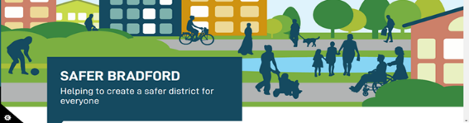

You can contact the MASH team through by telephoning 01274 431077.

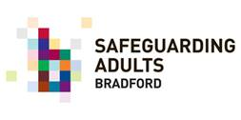
WHAT IS MAKING SAFEGUARDING PERSONAL ALL ABOUT?

It starts with a conversation………...

MSP is about Hope: helping me believe that things can be better.

MSP is about solving a puzzle: thinking creatively about how best to work with me, to help me be safer from abuse and achieve the outcomes I want for myself.

MSP Starts with a conversation
MSP starts with a conversation about what outcomes the person wants to achieve and what support they need to protect themselves from abuse.

This means
- At the start - Wherever possible, finding out the persons’ wishes and what outcomes they want to achieve at the start of any safeguarding work.
- During - Checking how much support the person needs and checking if the outcomes they want have changed during any safeguarding work.
- At the end - Checking that the safeguarding work has helped the person be safer and to achieve the outcomes they wanted.
MSP is about help to explore options: helping me look at what could change in my life and what support is around to make me happier and safer from abuse.
MSP is about listening: being believed and taking my wishes seriously, even if I sometimes need others to make a decision for me to keep me safe from abuse.

MSP is about being proud and valued: helping me believe that I’m worth it and that I deserve to be safe from abuse.

What do we mean by safeguarding outcomes?

Outcomes are about what the person wants to happen or what do they want to be different about their lives that would make them happier and safer from abuse.
It isn’t always possible to do what the person wants and sometimes other people might need to make decisions to keep the person safe.
Some people will need time and help to understand what support is available and what choices they have, but the starting point should always be a discussion about what the person wants to happen.
MSP is about empowerment: building on my strengths and things I can already do help me be more confident.

MSP is a double edged sword: being supported to make decisions that make me happier, even if this means living with some risk of abuse.

The Care Act says that ‘’Making Safeguarding Personal means it should be person-led and outcome-focused. It engages the person in a conversation about how best to respond to their safeguarding situation in a way that enhances involvement, choice and control as well as improving quality of life, wellbeing and safety.”

MSP is not an excuse for services to walk away just because I might say I don’t want any support.

MSP is not a barrier to sharing concerns of abuse with other agencies or people who support me.

MSP is not about always doing what I say I want, at all costs.

