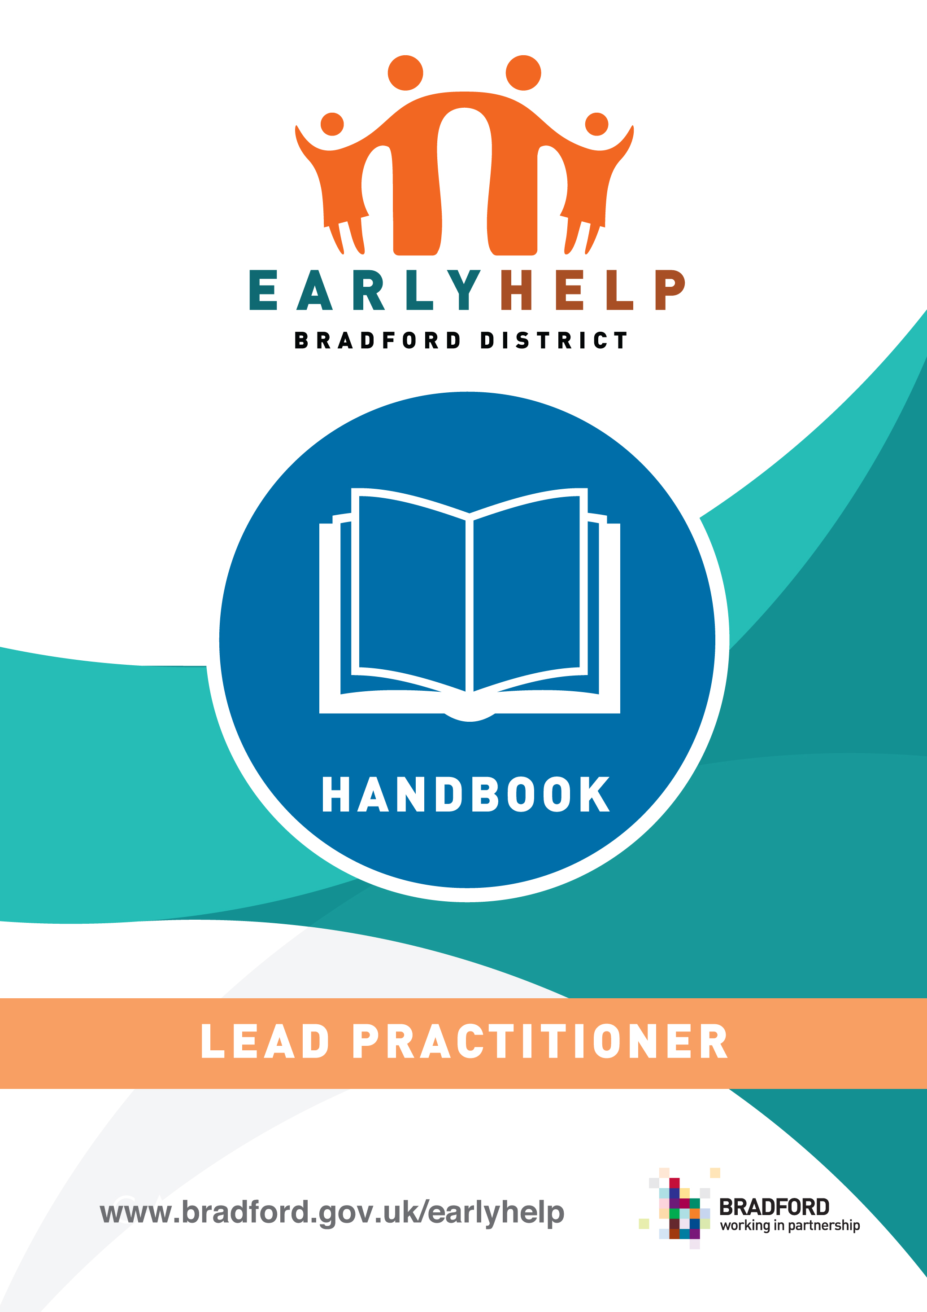

Table of Contents

What is Early Help? 3

What is a Lead Practitioner? 3

Key responsibilities 5

Who can be a Lead Practitioner? 6

Support for the Lead Practitioner 7

Management Support and accountability 7

For other supporting documents please see BSOL pages

Early Help is the term used to describe arrangements and services that respond to the needs of children, young people and their families as soon as problems start to emerge at any point in their lives, or when there is a strong likelihood that problems will emerge in the future. Section 10 of the Children Act 2004 requires each local authority to make arrangements to promote cooperation between the authority, each of the authority's relevant partners and such other persons or bodies working with children in the local authority's area as the authority considers appropriate. Further guidance is also provided in the Continuum of Need document .

Critical features of effective Early Help are:
- A multi-disciplinary approach that brings a range of professional skills and expertise to bear through a ‘Team Around the Child, Young Person / Family’
- A relationship with a trusted Lead Practitioner who can engage with the child / young person and their Parents and family (mother and father figures and extended family), and coordinate the support needed from other agencies.
- Practice that empowers families and helps them to develop the capacity to resolve their own problems.
- A holistic approach that addresses a child / young person’s needs in a wider context
- Simple, streamlined enquiry and assessment process and response
What is a Lead Practitioner?
The Lead Practitioner is the named professional, identified as the person who will be the family’s main point of contact while they need a coordinated early help package of support. They will be one of a number of practitioners already working with the family.
Lead Practitioners play a key role in the effective frontline delivery of services for vulnerable children with a range of additional needs. They are vital in ensuring that support is well coordinated, resources are used effectively and good early decision making leads to better outcomes for both children and their families.
This is not a definitive guide and each agency will have their own guidance setting out key responsibilities for their staff. It is designed to complement rather than replace any statutory or specialist guidance. This handbook is intended to clarify the role and responsibilities of the Lead Practitioner as well as other professionals working with vulnerable children and families, across the Continuum of Need and Risk in Bradford District.

Why are Lead Practitioners needed?
Extensive research and guidance emphasises the importance of good coordination when delivering early help to vulnerable families. Good quality key working is most effective when this is supported by:
• Strong multi-agency working
• Clear and consistent referral pathways to services
• Consistent decision-making processes based on a thorough assessment of risks and strengths within the family network
• Prompt, persistent, and flexible approach, based on listening to families and building on their strengths
• Regular review of progress and risk factors;
• Robust risk management;
• clear planning for case closure and for sustainability of good outcomes.
Families have said that they want one worker; they don’t want to have to repeat their story or have lots of professionals coming in and out. They want some practical support, such as help completing benefit forms, applying for housing, de-cluttering their homes; and they want to know what the bottom line is, so timely and honest conversations that explain consequences, providing both support and challenge to families is required. When early help work is not well coordinated, there is a risk that;
- Children and families have too many professionals involved with them;
- Children and families have to repeat their story often and do not feel listened to as a result;
- Children and families can fall between the gaps, when the needs of the whole family are not taken into account;
- Family experiences many and repeated interactions from different services, sometimes delivering conflicting or confusing messages;
- The voice of the child is not used to influence assessments and decision making;
- The family doesn’t get access to evidence based services;
- The family may miss out on receiving information and support to access local and community services themselves;
Such fragmentation causes confusion for everyone; it can cause delay in children receiving the support they need, and lead to poorer outcomes for children and young people.
What does a Lead Practitioner do?
A lead practitioner should undertake the assessment, provide help to the child and family, act as an advocate on their behalf and co-ordinate the delivery of support services. A GP, family support worker, school nurse, teacher, health visitor and/or special educational needs co-ordinator could undertake the lead practitioner role. Decisions about who should be the lead practitioner should be taken on a case-by-case basis and should be informed by the child and their family Working Together 2018

Key responsibilities include:
- Gaining and recording the family’s consent on the Early Help Assessment document
- Building and maintaining a trusting relationship with the family to secure their engagement and active involvement in the support process.
- Ensuring the child(ren) and young people remain central to decisions made about them or their care;
- Arranging and chairing the initial Team around the Family meeting;
- Supporting, encouraging and empowering the family to engage with the family support work;
- Ensuring each agency that is involved with the family contributes to the assessment and plan for support;
- Using the Early Help Assessment to put in place a SMART plan of support;
- Coordinating, monitoring and reviewing the plan for support so that it responds to changes in circumstances, and reflects the views and wishes of the family;
- Ensuring that children and young people are safeguarded, following safeguarding protocols and the Continuum of Need and Risk Tool to escalate concerns when the Team around the Family is no longer able to keep children safe or where specialist services are required;
- Inputting all stages of the assessment , plan, review and closure (on the Partner Portal of Early help Module);
- Bringing the support package to an end when the family’s needs have been met.
Who can be a Lead Practitioner?
The lead practitioner can be any professional already working with or known to the family- it will not necessarily be the agency who see the family the most (e.g. school) A lead practitioner can include but is not limited to roles such as ; Personal Advisers, Health Visitors, Midwives, GP’s, Paediatricians, Social Workers, Youth Justice Service Workers, Youth Workers, Family Support Workers, Substance Misuse Workers, Mental Health Workers, Early Years Workers, Educational Welfare Officers, Housing Officers, Community Children's Nurses, School Health Practitioners, Teachers and school support staff such as Learning Mentors and practitioners from voluntary, community and social enterprise organisations etc.
How is the Lead Practitioner identified?
The Lead Practitioner is identified from the multi-agency group of practitioners working with the child, young person or family. They are chosen through a process of discussion and agreement. Decisions about who should be the lead practitioner should be taken on a case-by-case basis and should be informed by the wishes of the child and their family. The Early Help assessment and initial TAF meeting will assist the process of identifying the Lead Practitioner
In some circumstance the Lead Practitioner may need to be allocated in line with statutory guidance where child protection processes are in place i.e. Working Together 2018. Once the referral has been accepted by local authority children’s social care, the lead practitioner role falls to a social worker.
Initially the Lead Practitioner is the professional who identifies that the family needs a coordinated support package and completes the Early Help Assessment. The initial TAF meeting should then offer further opportunity to discuss with the family and professionals involved who is best placed to be the Lead Practitioner going forward. The Lead Practitioner can change over time as the family’s needs change. Further advice can be provided by the Early help Coordinators or in some circumstances reference could be made to the process for resolving multi agency professional disagreements and escalation .

Supporting the Lead Practitioner
Lead Practitioners need high quality professional supervision and line management support from their own agency so they can carry out their functions effectively.
Other professionals involved with the child/family should support the Lead Practitioner , for example by committing to attending meetings, taking notes of meetings, sharing information and following through actions as agreed. For example if the Lead Practitioner cannot attend a meeting due to annual leave, short-term sickness other professionals should continue, as far as possible, to ensure that families receive seamless support.
Lead practitioner training will be available from September 2020 for key staff that are expected to undertake the role regularly.
Early Help Coordinators
Most families who need some additional support will achieve positive outcomes through an integrated team around the family, drawn from universal service provision, e.g. schools, health visiting. Where the family and the team are struggling to make progress to achieve outcomes, the skills of an Early Help Coordinator can be drawn upon.
Early Help Coordinators work alongside Lead Practitioners and others in universal services offering:
Consultation: about individual children and families using the Continuum of Need and Risk Tool ,Signs of Safety methodology and supporting the Lead Practitioner to analyse evidence when children’s needs have not been met through the plan.

Co-working: supporting Lead Professionals with information sharing to enable a good quality assessment to be completed, co chairing initial meetings, or supporting a TAF if required ( for example where there are disagreements, or where progress is not being made)

Coaching: through face to face meetings to ensure that assessments and plans are accurate, SMART and meet the needs of the whole family; acting as a role model for effective practice that relies on assertive, persistent, time bound and challenging style of casework;

Collaborating: to co- design bespoke packages of support, guidance and practical tools to support practitioners when working with families;

Ensuing Consistency, by quality assuring multi-agency Early Help plans and providing feedback to the Lead Practitioner and their manager.
Management Support and Accountability
The Lead Practitioner is accountable to their home agency for all aspects of their role, including that of Lead Practitioner. They are not directly accountable for services delivered by other agencies, but they do take a lead responsibility for the quality and effectiveness of the plan and the support package for the family. Safeguarding decisions are the responsibility of the designated lead for Safeguarding in their own agency. Lead Practitioners should receive supervision and be afforded the opportunity for reflection on their work, within their own line management arrangements.
To compliment the support and management oversight offered through their own agency, Lead Practitioners are supported in this role by Early help Coordinators who facilitate a peer network of support in the Locality, regular workforce development events, and provide face to face consultation and advice.

Ref to Working Together 2018, Munro review of child protection: final report - a child-centred system , Early intervention: the next steps Graham Allen 2011,Fair Society, Healthy Lives , the Marmot Review 2010, Troubled Families Guidance , How services prevent young people entering care: edging away from care Ofsted 2011,
Family is used to refer to the child(ren), young people and parents and carers whether or not they all live in one household.
Not currently operational- date for implementation to be agreed.

