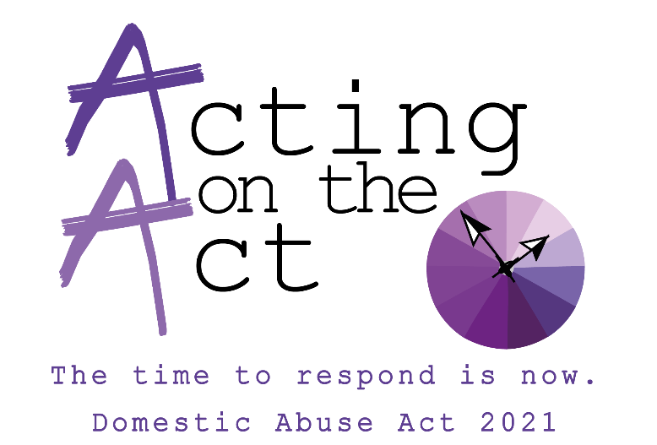

In February, we held the first of a series of learning events considering the domestic abuse act and how it works in practice.
This session focussed on the 3 key elements of the Domestic Abuse Act:
- new offence of non-fatal strangulation
- an extension to the revenge porn offence
- clarification of the ‘rough sex’ defence.
The session was hosted by Lindsay Bridge and Sue Roberts of Bradford Council’s Domestic Abuse and Sexual Violence Team and the guest speakers were as follows:
- Ruth Davison – Manger of Domestic Abuse and Sexual Violence team at Bradford Council
- Alan Raw – Det Chief inspector West Yorkshire Police Safeguarding Unit
- Lee Berry - Adult Lead including Domestic Abuse
- Nicola Pringle - Det Superintendent West Yorkshire Police Service Delivery Manager (DA), Safeguarding Central Governance Unit
- Holly Johnson – Det Sergeant Bradford Domestic Abuse Partnership
- Alisha Thomas – Operation Manger West Yorkshire ISVA service victim support
- Tracy Teale – Lead sex worker ISVA from the Lotus project
- Linda McLean – Community hub team leader for ISVA and 12 weeks IDVA teams
- Jane Gregory – Service manager Bradford Rape Crisis

Please find a link below of the recorded session.
https://youtu.be/H-tzKmx9Iyg

