Bradford Safeguarding Adults Board  
Annual Report  
 2023 - 2024  
Final

Contents

2 Independent Chair Foreword 2

3 About Bradford 2

4 What is Adult Safeguarding? 3

5 Role of Bradford Safeguarding Adults Board 4

6 Safeguarding Activity 5

6.1 Making Safeguarding Personal……………………………………………………...5

6.2 The Real Time Service User Feedback Project …………………………............. 6

7 Development of the BSAB Strategic Plan 2023 – 2026 7

8 Delivery Against Strategic Priorities 2023 -2024 8

8.1 Highlights of the Work Undertaken from 2023 – 2024 …………………………. 9

8.2 BSAB Development Day November 2023 ………………………………….11

9 Learning from Safeguarding Adult Reviews 14

10 Communication and Stakeholder Engagement 15

11 Safeguarding Events and Training Programme 16

12 Looking Ahead 17

13 Acronyms 17

14 How to Report a Safeguarding Concern 18

# Independent Chair Foreword

|  |
| --- |
| A person wearing a purple shirt and tie  Description automatically generatedWelcome to the annual report of the Bradford Safeguarding Adults Board (BSAB), which outlines the ongoing efforts by our multi-agency partners to prevent, protect and safeguard adults against abuse and neglect across the Bradford District.  Last year BSAB set out three key ambitions in its strategic plan, which guide our work and priorities. These are to improve awareness of adult safeguarding across our communities and partner organisations; prevention of abuse and neglect; and engagement and making safeguarding personal. This report highlights the progress that has been made against these ambitions, along with highlights of specific pieces of work being undertaken across the partnership, despite continuing high demand for services and high levels of activity across our multi-agency partnership. Despite this, we continue to see a year-on-year increase in the number of people who are subject to safeguarding inquiries being involved in deciding the outcomes they would like.  At the BSAB Development Day, partners demonstrated their continued commitment to working collaboratively to progress our strategic ambitions with a special focus on lived experience voice.  Whilst we are making good progress on our strategic ambitions, there is more for us to do, and we have set out several key activities and projects for the year ahead.  I’d like to send my thanks to the practitioners for all your work you do to make safeguarding personal and effective for the people of Bradford District.  **Dr. Terry Hudsen**  **BSAB Independent Chair** |

# About Bradford

* 546,400 people live in Bradford - an increase of 23,900 since 2011. Of which, 51% are women and 49% are men.
* Bradford is the 5th largest local authority in England.
* Life expectancy at birth is 77.3 years for males & 81.5 for females.
* Since 2011 there has been an increase of 19.6% in people aged 65 years and over, an increase of 2.4% in people aged 15 to 64 years, and an increase of 1.9% in children aged under 15 years.
* As of 2021, Bradford is the third most densely populated of Yorkshire and The Humber's 21 local authority areas, with around 11 people living on each football pitch-sized area of land

56.7% of the Bradford District population identified as White British, 25.5% identified as Pakistani – the second largest percentage nationally. 2.6% identified as Indian, 2.3% identified as Bangladeshi, 2.7% identified as Mixed or Multiple ethnic groups, 2% identified as Black. This question included a new category, Roma and 1,583 of the District’s population (0.3%) identified as Roma.

Data has been taken from the 2021 census

<https://www.ons.gov.uk/visualisations/censuspopulationchange/E08000032/>

<https://ubd.bradford.gov.uk/about-us/2021-census/>

# What is Adult Safeguarding?

**“Safeguarding means protecting an adult’s right to live in safety, free from abuse and neglect”**

**(The Care Act, 2014)**

**The aims of adult safeguarding are to**:

* **prevent harm** and **reduce the risk of abuse or neglect** to adults with care and support needs
* safeguard adults in a way that supports them in **making choices** and **having control** about how they want to live
* promote an approach that concentrates on **improving life** for the adults concerned
* raise public **awareness** so that communities as a whole, alongside professionals, play their part in preventing, identifying and responding to abuse and neglect
* provide **information and support** in accessible ways to help people understand the different types of abuse, how to stay safe and what to do to raise a concern about the safety or well-being of an adult
* address what has **caused** the abuse or neglect

Abuse and neglect can take various forms including physical abuse, domestic abuse, sexual abuse, psychological or emotional abuse, financial or material abuse, modern slavery, discriminatory abuse, organisational or institutional abuse, neglect and acts of omission and self-neglect.

Under Section 42 of the Care Act, 2014 the local authority has a responsibility to undertake an Enquiry where there is a concern that an adult with care and support needs is unable to protect themselves when experiencing or at risk of abuse or neglect. If the criteria in Section 42(1) are met, then the local authority must conduct an Enquiry and decide on any action under section 42(2).

**Safeguarding duties apply to an adult who:**

* Has needs for care and support (whether or not the local authority is meeting any of those needs) **and**;
* Is experiencing, or is at risk of, abuse or neglect; **and**;
* As a result of those care and support needs is unable to protect themselves from either the risk of, or the experience of, abuse or neglect.

**The Six Statutory Principles of Adult Safeguarding**

**Empowerment**

**People are supported and encouraged to make their own decisions and informed consent.**

*“I am asked what I want as the outcomes from the safeguarding process, and this directly inform what happens.”*

**Prevention**

**It is better to take action before harm occurs.**

*“I receive clear and simple information about what abuse is. I know how to recognise the signs, and I know what I can do to seek help.”*

**Proportionality**

**The least intrusive response appropriate to the risk presented.**

*“I am sure that the professionals will work in my interest, and they will only get involved as much as is necessary.”*

**Protection**

**Support and representation for those in greatest need.**

*“I get help and support to report abuse and neglect. I get help so that I am able to take part in the safeguarding process to the extent to which I want.”*

**Partnership**

**Services offer local solutions through working closely with their communities. Communities have a part to play in preventing, detecting and reporting neglect and abuse.**

*“I know that staff treat any personal and sensitive information in confidence, only sharing what is helpful and necessary. I am confident that professionals will work together and with me to get the best result for me.”*

**Accountability**

**Accountability and transparency in delivering safeguarding.**

*“I understand the role of everyone involved in my life and so do they.”*

# Role of Bradford Safeguarding Adults Board

The Care Act 2014 Statutory Guidance confirms that “the main objective of a SAB is to assure itself that local safeguarding arrangements and partners act to help and protect adults in its area” who meet the safeguarding criteria (chapter 14.133)

The Care Act 2014 introduced Safeguarding Adults Boards and gave them the responsibility to seek assurance that there are effective local safeguarding arrangements.

Bradford Safeguarding Adults Board is made up of senior people from organisations that have a role in helping and preventing adults in the Bradford District being subject to neglect and abuse.

The overarching purpose of a SAB is to safeguard adults who cannot protect themselves from abuse and/or neglect because of their care and support needs. It does this by:

* assuring itself that local safeguarding arrangements are in place as defined by the Care Act 2014 and statutory guidance.
* assuring itself that safeguarding practice is person-centred and outcome focused.
* working collaboratively to prevent abuse and neglect where possible.
* ensuring agencies and individuals give timely and proportionate responses when abuse or neglect have occurred.
* assuring itself that safeguarding practice is continuously improving and enhancing the quality of life of adults in its area.

The Board has three core duties. These are:

1. Develop and publish a strategic plan setting out how we will meet our objectives and how our member and partner agencies will contribute.
2. Publish an annual report detailing how effective our work has been.
3. Commission Safeguarding Adults Reviews (SARs) for any cases which meet the criteria for these.

Bradford Safeguarding Adults Board has met four times, with an additional two Board development sessions for members to progress with the strategic priorities. These meetings have been well attended by both statutory and non statutory partners.

The Board is funded by the West Yorkshire Integrated Care Board, Bradford District Metropolitan District Council, and West Yorkshire Police. This enables the Board to fund specific workstreams, commission an Independent Chair and a safeguarding partnership business unit to support its work.

For more information about BSAB please visit the [SaferBradford Website](https://saferbradford.co.uk/resources/adults/bradford-safeguarding-adults-board/)

# Safeguarding Activity

A key statutory function of the SAB is to seek assurance that the local authority facilitating and recording Section 42 enquires.

Section 42 enquiry must take place if there is reason to believe that abuse or neglect is taking place or is at risk of taking place, and the local authority believes that an enquiry is needed to help it to decide what action to take to support and protect the person in question.

In the past year, a total of 7,478 contacts were raised by individuals concerned about potential abuse or neglect. This represents a 19% increase compared to the previous year.

Out of these contacts, 2,824 cases were investigated further, marking a 9% rise from the previous year. Of the cases investigated, 46% fell under the category of Physical Abuse, followed by Neglect and Acts of Omission at 22%. Other recorded categories of abuse included, Financial or Material Abuse, Psychological Abuse, Sexual Abuse and Self-Neglect

Data indicates that 35% of the enquiries investigated further were related to risks within the individual’s own home, while 29% were associated with residential care homes. Additional categories recorded include Care Home – Nursing, Hospital – Mental Health, and Supported Accommodation, among others.

|  |  |  |  |  |
| --- | --- | --- | --- | --- |
| 18-64 | 65-74 | 75-84 | 85-94 | 95+ |
| 42% | 12% | 21% | 21% | 4% |

**Age Band - Section 42 only**

**Ethnicity - Section 42 only**

|  |  |  |  |  |  |
| --- | --- | --- | --- | --- | --- |
| White | Mixed/ Multiple | Asian/ Asian British | Black / African / Caribbean / Black British | Other Ethnic Group | Not Known |
| 48% | 11% | 7% | 1% | 2% | 29% |

## Making Safeguarding Personal

Making Safeguarding Personal (MSP) is not simply about gaining an individual’s consent, although that is important, but also about hearing people’s views and wishes about what they want as an outcome. The approaches of agencies and services to adult safeguarding should be person-led and outcome-focused. The Care Act 2014 emphasises a personalised approach to adult safeguarding that is led by the individual, not by the process. It is vital that the adult feels that they are the focus, and they have control over the process.

This means that people are given opportunities at all stages of the safeguarding process to say what they would like to change; this might be about not having further contact with a person who poses a risk to them, changing an aspect of their care plan, asking that someone who has hurt them to apologise, or pursuing the matter through the criminal justice system

Bradford Safeguarding Adults Board have co-produced, along with those with lived experience, a toolkit and resources that can be used to explain MSP and how practitioners can embed MSP principles into practice. This can be found here on the [SaferBradford Website](https://www.saferbradford.co.uk/resources/adults/making-safeguarding-personal/)

**Making Safeguarding Personal Data – (Section 42 only)**

The collection and recording against MSP data has greatly improved since the previous year. The table below shows from the Section 42 safeguarding enquiries, 87% of those people subject to the enquiry were asked about the outcomes they would like. Sometimes it is not always possible to ask individuals due to their personal situation, however Social Workers will always endeavour to do so.

|  |  |  |  |  |  |
| --- | --- | --- | --- | --- | --- |
| Collection Year | Yes they were asked and outcomes were expressed | Yes they were asked but no outcomes were expressed | No | Don’t Know | Not Recorded |
| 2024 | 76% | 11% | 7% | 0% | 6% |
| 2023 | 67% | 10% | 7% | 0% | 16% |
| 2022 | 44% | 11% | 10% | 0% | 34% |

## The Real Time Service User Feedback Project

During this recording period 80 adults were invited to take part in a pilot scheme to obtain real time user feedback. From those that were contacted just under half (36 adults) took part. This project aimed to get independent feedback from individuals (or their carers) who had been subject to Section 42 safeguarding enquiries. The project involved individuals who volunteered, answering questions in relation to their experience. The questions participants answered were:

* Were you involved in discussions about why you were at risk?
* Did you understand why people did what they did to try to keep you safe?
* Did you feel that people listened to you in conversations and meetings about helping you feel safe?
* How happy are you with the end result of what people did to try and keep you safe?
* Do you feel that you are safer now?

A brief analysis of the results from this pilot showed that 35 out 36 adults were fully involved in discussions about why they were at risk, only 1 adult said they were fairly involved. 32 of these adults understood why people did what they did to try and keep them safe and felt that they had been listened to and involved in conversations and meetings. 28 adults were very happy with the end result, and 8 adults were quite happy. Of those that took part 32 adults expressed that they feel a lot safer now and 4 adults said they feel a bit safer.

To build on this project BSAB members have agreed to incorporate the questions in wider service user engagement activities including the annual Adult Social Care Survey.

# Development of the BSAB Strategic Plan 2023 – 2026

The strategic plan was developed by Bradford Safeguarding Adults Board partners in consultation with members of the Board’s Executive and its subgroups. This strategy was developed with contributions and oversight from members of the established Safeguarding Voice Group. The Safeguarding Voice Group membership is made up of those with lived experience of abuse and neglect or have a caring responsibility for those that have.

The strategic plan is based around three key ambitions that will guide our work and priorities:

1. Improve Awareness of Adult Safeguarding Across All Communities and Partner Organisations
2. Prevention of Abuse and Neglect
3. Engagement and Making Safeguarding Personal

The strategy sets out how BSAB intends to achieve each of the three key priorities and will be the Board’s blueprint for the next three years. It follows on from a previous three-year strategic plan which concluded in March 2023. Some areas of work identified during the progression of this three-year plan have been incorporated into our new plan to ensure continued focus and development in these key areas.

The subgroups of the Board are pivotal in supporting BSAB to achieve its objectives and continue to deliver on campaigns and develop tools to support practitioners and citizens in understanding and responding to adult safeguarding concerns.

**Bradford Safeguarding Adults Board Structure**

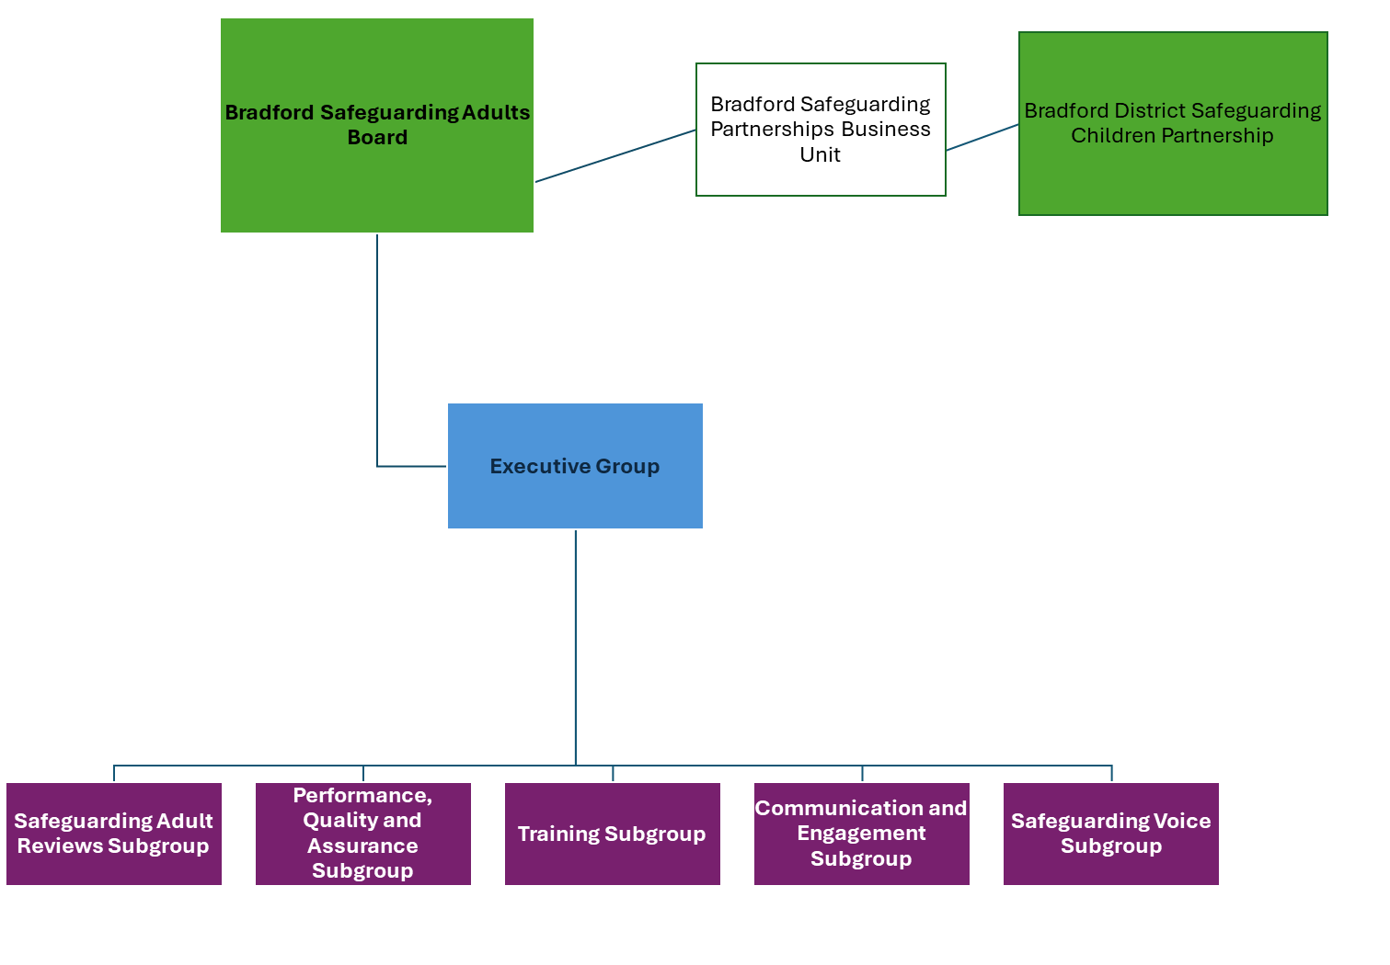

# Delivery Against Strategic priorities 2023 - 2024

**Priority One – Improve Awareness of Adult Safeguarding Across All Communities and Partner Organisations**

**Desired Outcome:** People have access to clear and simple information about abuse and neglect and they are confident to report it.

**People will say**: “I receive clear and simple information about what abuse and neglect is, how to recognise the signs that this is occurring and what I can do to seek help.”

**What we have done towards the delivery of this priority:**

1. We have gathered evidence from our diverse communities to demonstrate that they understand what safeguarding is and how they can access support via focus groups and surveys. We have done this through community engagement activities, supporting the work of local partners.
2. We have gathered evidence of awareness and understanding of adult safeguarding duties amongst staff across the partnership, via focus groups and surveys. This includes undertaking practitioner forums highlighting the work of the Safeguarding Adults Board and gathering information regarding emerging safeguarding themes.
3. We have provided a comprehensive multi-agency safeguarding training offer. This has ensured that there are opportunities for multi-agency training, learning and development around safeguarding adults is available to staff in all partner agencies, as appropriate to their role.
4. We have enhanced our intelligence report regarding adult safeguarding, with the aim to increase the SAB’s understanding of prevalence of abuse and neglect locally that builds up a picture over time – with actions flowing into our annual business plan and subgroups, holding partners to account, and improving the outcomes for adults at risk in the Bradford District.

**Priority Two – Prevention of Abuse and Neglect**

**Desired Outcome:** Adults at risk are identified early and have their needs met promptly and effectively.

**People will say**: “I feel safe and am supported to understand and manage any risks.”

**What we have done towards the delivery of this priority:**

1. We have ensured that our local safeguarding plans, policies, and procedures, including multi- agency policies are accessible and publicised appropriately – setting out the role, responsibility, and accountability for each agency and professional group.
2. We have implemented a multi-agency training strategy and a revised training programme, informed by current and future training needs based on local and national learning from SARs, legal frameworks/ changes and additions and the work of BSAB. We have also agreed a Quality Assurance Framework which will be ensure quality of training delivered and the capability to measure impact of the multi-agency training offer.
3. We have worked to ensure our Safeguarding Adult Review processes facilitate identification and application of key learning. We have reviewed key areas of the SAR Governance Framework, enhancing our practice of recruiting review authors and collaboration with parallel processes.

**Priority Three – Engagement and Making Safeguarding Personal**

**Desired Outcome:** Adults at risk and practitioners feel empowered for their voices to be heard in safeguarding practice and policy development.

**People will say**: “I am asked what I want as my outcomes from the safeguarding process, and these directly inform what happens” and “I get help and support to report abuse and neglect. I get help so that I am able to take part in the safeguarding process to the extent to which I want.”

**What we have done towards the delivery of this priority:**

1. We have gathered feedback from people who have lived experience of the safeguarding process on whether they understood the safeguarding process, felt listened to, and their desired outcome has been reached (via outcomes-based questions based on [six safeguarding principles ‘I statements’](https://www.local.gov.uk/sites/default/files/documents/Practice_Tool_5-six_core_principles%20FINAL%20WEB.pdf)).
2. We have gathered feedback from family, carers, advocates, and wider family members of the person at risk (with their consent) about whether they understood the safeguarding process, felt the person was listened to, and feel the person's desired outcome was reached (via outcomes-based questions).
3. We have continued to support the Safeguarding Voice Group so that the voices of people in our communities are heard and inform our work. The group membership and terms of reference have been reviewed and new members have joined to broaden the reach and diversity of the group.

## Highlights of the work undertaken from 2023 – 2024

With the support of the Business Unit, the Independent Chair conducted a series of Practitioner Forums in March and April 2023. These forums saw participation from diverse frontline practitioners from the Safeguarding Adult Board partnership. Key themes from these discussions included Neglect, Self-Neglect, Hoarding, and Financial Abuse. As a result of these practitioner forums, information regarding the multi- agency training offer concerning these themes was shared with the practitioners enabling them to access training on Financial Abuse and Making Safeguarding Personal training.

The Performance, Quality and Assurance Subgroup (PQAG) have continued to progress the development of the BSAB Intelligence Report with the aim to encompass safeguarding data from the entire BSAB partnership. This includes a quarterly in-depth analysis of two specific data areas. The focus of these deep dives has included Neglect and Financial Abuse, chosen due to their frequent mention at the practitioner forums. This has enabled members to explore the relationship between emerging front line safeguarding issues, safeguarding referrals and section 42 enquiries. The PQAG Subgroup will continue to identify themes to potentially explore - such as the location of abuse, repeated referrals, and the promptness of S42 enquiries.

Working to improve communication and engagement priorities and activities, the Communication and Engagement Subgroup have refreshed their Terms of Reference and Strategy. Priority areas were identified based on feedback by members and BSAB subgroup chairs. Some of the key initiatives agreed and progressed include:

* Public Transport Safety: The Safeguarding Voice Group is partnering with public transport providers to enhance safeguarding awareness.
* Financial Abuse/ Scams: To continue to work with West Yorkshire Partnership to share their insights on scams gleaned, building on findings from the conference held in Safeguarding Adults Week. We have ensured that this topic is also incorporated into the induction offer for elected members.
* Safe Space Initiative: Hertfordshire's 'Keep Safe' and 'Think Safe' schemes were considered potential blueprints for preventing hate crimes and educating individuals on self-protection during emergencies.
* Collaborative Efforts: In collaboration with the Community Safety Partnership, efforts are being made to raise awareness about various forms of abuse, including Domestic Abuse, Modern Slavery, FGM, and Honour Based Abuse.
* Self-Neglect Practice Guidance: There are ongoing plans to formulate a practice guidance on Self-Neglect, with related training and awareness campaigns to follow.
* SAR Learning Dissemination: The group is working towards establishing a protocol for sharing insights from Serious Adult Reviews (SARs) with partners and gathering their feedback.
* Social Media Engagement: The group aims to amplify the SAB's social media visibility. They plan to leverage national observances, weekly themes, and local events that align with their objectives to broaden their outreach.

To support the work of the Safeguarding Adult Reviews (SAR) Subgroup, a case management system has been procured. This is a direct outcome from the work undertaken by The Practice Review Task, and Finish Group and will improve the efficiency and effectiveness of reviews for adults, children and domestic homicides. A Case Review Coordinator has been recruited into the Business Unit and they will begin to support partners to use the new system, as well as supporting the work of the SAR Subgroup.

The All-Age Exploitation subgroup has been making the most of opportunities to share and receive learning from local, regional and national safeguarding practitioners. This has included an understanding of the work of "Breaking the Cycle", a service primarily targeting young individuals susceptible to criminal exploitation. This includes involvement in serious crime, urban street gangs, county lines, and trafficking, focusing on those trapped in the supply, use, or possession of drugs and weapons. "Breaking the Cycle" is a referral and response service working with the police. They employ Youth Work Practitioners stationed at BRI, Huddersfield, and Halifax Hospitals to assist young individuals who arrive at A&E following violent incidents.

Members have also received presentations from Palm Cove Society, on abuse related to Accusations of Witchcraft and Spiritual Possession (ALWSPA). This abuse includes practices like Black Magic, Exorcism, and Spiritual Possession, often used to control and coerce victims of Human Trafficking and Modern Slavery. During the presentation, several case studies were shared and highlighted examples of this type of abuse in the UK. Palm Cove Society promotes the importance of respectful communication methods and understanding different beliefs in effectively engaging with communities affected by ALWSPA.

The All-Age Exploitation Subgroup has also developed a comprehensive branding strategy for the exploitation agenda centred on Prevent, Protect, Pursue, and Prepare principles. This initiative, funded by the Community Safety Partnership, aims to enhance the visibility and impact of the subgroup's work and promote a unified approach to tackling exploitation across the district.

This year, the Exploitation Hub has continued to develop. Updates to the Hub's structure and operations, including creating performance measures and integrating feedback from service users, have strengthened its capacity to address exploitation effectively. The subgroup has emphasised maintaining robust links between adult and children's services, ensuring a comprehensive approach to transitional safeguarding.

Members of the Training Subgroup have developed a Multi-Agency Training Quality Assurance Framework which aims to ensure that training is delivered to a consistently high standard and that a process exists for evidencing that standards agreed by the respective Boards have been reached. The framework incorporates the strengthened minimum standards with built-in tools for evaluation and impact. Following the successful roll-out of the Recognising and Responding to Abuse Train the Trainer course, a network of 10 multi-agency trainers have been trained to support the delivery of multi-agency training.

The Safeguarding Adult Reviews (SAR) Subgroup have progressed with ensuring the actions from three previously published reviews, and these action plans have now been completed and approved by the Board. The SAR Subgroup will continue to develop a ‘one page’ summary of learning from these SARs including actions – and will be developed for each of these SARs. This will be useful in providing an overview of recommendations, learning and impact for partners and practitioners.

The SAR Subgroup is working towards a framework that promotes positive learning from the worst examples of care and neglectful abuse cases and to ensure that it is safe for frontline practitioners to be critically reflective and engage in these processes. They are assessing the methods of taking this learning forward, be it the commissioning of external authors or utilising more agile internal skilled resources across the system to create more timely responsive ways of creating safe spaces for practitioners to gather and learn as a system.

Over the last twelve months, the Project and Engagement Officer has undertaken a Real-Time Service User Feedback pilot. This has been a time-intensive piece of work but provides triangulation with other evidence as seen in the Intelligence Report of good adherence to Making Safeguarding Personal.

## BSAB Development Day November 2023

**"Ensuring the lived experience voice is central to practice, strategy and assurance."**

Bradford Safeguarding Adults Board (BSAB) convened for a Development Day in November 2023, aimed at enhancing safeguarding practices and strategies within the district. This day brought together representatives from all member agencies to focus on integrating the lived experience voice into safeguarding strategy and practice, reflecting a commitment to making safeguarding personal and effective for all community members. The primary objective of the Development Day was to explore and expand the role of lived experiences in shaping safeguarding strategies and practices. The day was structured to facilitate a deep dive into the history of BSAB, set future aspirations, and identify practical steps towards integrating lived experiences into the safeguarding framework.

**Key activities on the day included:**

**Exploration of BSAB History**

Participants began the day by reviewing the journey of BSAB, understanding its foundations, achievements, and areas for growth. This historical context set the stage for a forward-looking discussion on integrating lived experiences.

**Setting Aspirations**

Members collaboratively set aspirations for BSAB, focusing on how lived experiences could be more effectively captured and utilized in safeguarding work. These aspirations aimed to ensure that safeguarding practices are not only responsive but also preemptive in addressing the needs of those at risk.

**Identifying Challenges and Blockers**

A critical part of the day involved identifying challenges and blockers that could hinder the integration of lived experiences. Participants engaged in open discussions to bring forth issues such as resource limitations, systemic barriers, and the need for cultural shifts within organisations.

**Group Work on Strategy, Practice, and Assurance**

Participants were divided into three focus groups concentrating on strategy, practice, and assurance. Each group explored specific actions and initiatives that could support the integration of lived experiences within their focus areas.

**Refinement of Aspirations and Action Planning**

The day concluded with each group presenting their refined aspirations and a list of actionable steps. These actions were aimed at bridging the gap between current practices and the aspirational state where lived experiences are central to safeguarding work.

**Outputs from the Workshop**

The Development Day resulted in a series of actionable steps, designed to align BSAB's focus towards a more inclusive, responsive, and person-centred safeguarding approach. These steps are detailed in an accompanying table that outlines the actions, reasons, strategic priorities, responsible subgroups, and key stakeholders involved.

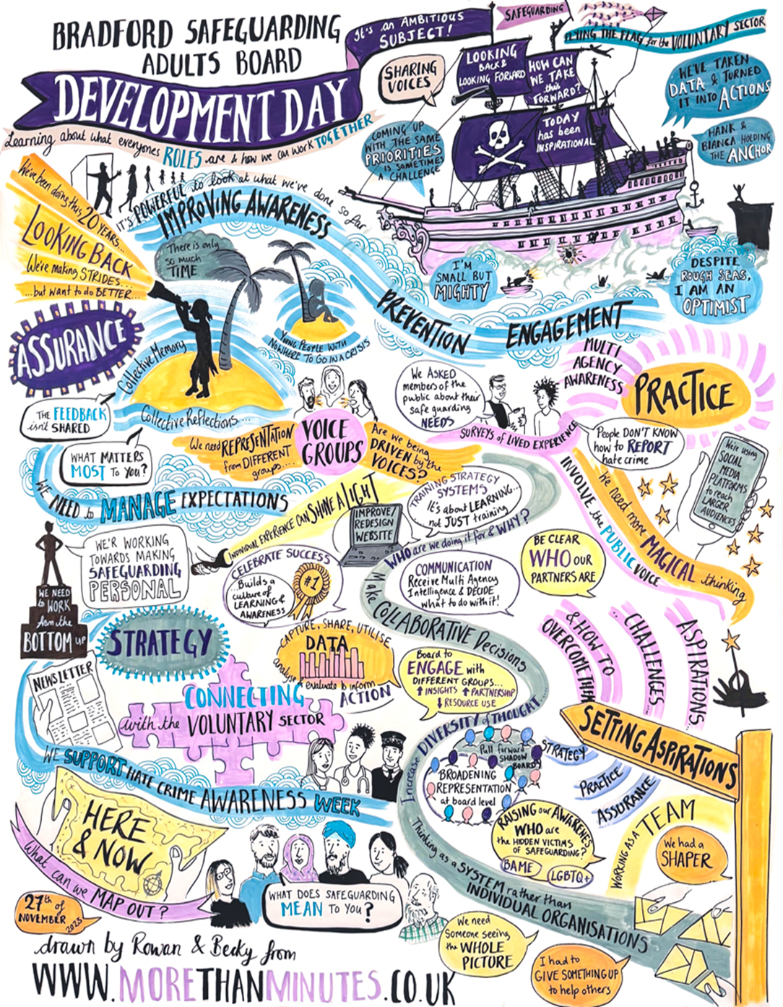

# Learning from Safeguarding Adult Reviews

A key statutory duty of the SAB is to carry out Safeguarding Adult Reviews (SARs) as stipulated under Section 44 of the Care Act when:

*‘….an adult in its area dies as a result of abuse or neglect, whether known or suspected, and there is concern that partner agencies could have worked more effectively to protect the adult'.*

*SABs must also arrange a SAR if an adult in its area has not died, but the SAB knows or suspects that the adult has experienced serious abuse or neglect*.

The purpose of a SAR is to identify learning and make recommendations, to **improve future practice** and to achieve better outcomes for adults at risk. It is not to re-investigate or to apportion blame.

In the past year, BSAB has completed one discretionary Safeguarding Adults Review

|  |
| --- |
| **SAR Shirley** |
| Background:  In October 2022 Bradford Safeguarding Adults Board commissioned a discretionary Safeguarding Adult Review (‘SAR’) into the death of ‘Shirley’. Shirley died in May 2022 (aged 67) from cervical cancer. Shirley also had a number of health issues including diabetes, pressure ulcers, asthma and had broken both her hips in the past. BSAB agreed that a discretionary SAR should be carried out as, although there is no indication that abuse or neglect contributed to her death, Shirley was in need of care and support, abuse or neglect was suspected and there was reasonable cause for concern about how persons with relevant functions worked together to safeguard her.  Key Themes from the Review include:   * Ensuring the effective use of safeguarding process to escalate concerns and secure multi-agency risk management in this case. * Safeguarding systems response to domestic abuse and elder abuse, in particular when this involves a carer. * Embedding concepts of coercion and control, and how these can impact on decision-making, across the professional network. * Ensuring the effectiveness of hospital discharge protocols.   The recommendations and actions from this review have been aligned with those from SAR Jack and the following actions have been already taken:   * The Integrated Health and Care workstream has recently undertaken work to review the discharge policy across the district’s two Acute Trusts. * Since the period under review in this case, there have also been significant changes to hospital discharge processes introduced through the Department for Health and Social Care’s Hospital Discharge and Community Support Guidance. * Bradford Safeguarding Adults Board has developed and implemented a multi-agency Professional Disagreement and Escalation Policy to support practitioners when there is a professional difference of opinion. * SAB works in partnership with the Domestic Abuse and Sexual Violence Board and are sharing the learning from this case with all agencies through internal and multi-agency training with a focus on Carer Strain and Domestic Abuse in Older people. |

# Communication and Stakeholder Engagement

The Safeguarding Voice Group is made up of people who use services, carers and interested members of the public that work with the Bradford Safeguarding Adults Board.

The aims of the Safeguarding Voice Group are to:

* To support communication and engagement activities undertaken by SAB partners. This may mean helping to review and create information and publicity materials like leaflets, guides, website, posters, etc.
* To provide opportunities for members to raise questions about safeguarding topics and seek advice on issues.
* To provide opportunities for members to share what is working well with safeguarding in Bradford and what is not working so well.

The Safeguarding Project and Engagement Officer has supported the work of the Safeguarding Voice Group and undertaken key activities to raise awareness of safeguarding across the district, a campaign of attendance at events took place across several locations including:

* Broadway Shopping Centre in Bradford in June 2023 as part of Safeguarding Week activities.
* The Learning Zone, Bradford
* Shipley College Fresher’s Fair
* Bradford College Fresher’s Fair

Each event allowed meaningful discussion with a wide range of people from our community and an anonymous survey was undertaken at each event asking individuals to answer the question ‘what does safeguarding mean to you’. Collated results were fed back to SAB and although results indicated a good knowledge in some of our residents, there were a number of very honest answers that underpinned the need for more work to raise awareness of the different types of abuse and neglect.

At each event, a range of resources were given out to the public including leaflets on Mate and Hate Crime (co-designed with the Safeguarding Voice Group), posters and the newly created ‘contact cards’. These cards contain contact details to report a concern as well as a QR code to provide a link to the Saferbradford website. Links have also been made with several food banks across the district and a range of resources provided for notice boards, staff and volunteers.

Communication and stakeholder engagement is led by the workstreams identified through the Communication and Engagement Subgroup. During this reporting period these workstreams have included a stakeholder review of the SaferBradford website to gain an understand of accessibility issues, and the user journey. The results of this engagement will form a wider project on refreshing the website during 2024. Members of the subgroup have also supported the development of a Hate Crime resources by spending the day working alongside Keighley and Craven People First members in order to plan, script and film a series of scenarios depicting how a victim of Hate Crime could feel.

# Safeguarding Events and Training Programme

The multi-agency safeguarding training offer is available on the SaferBradford website, this includes:

**Financial Exploitation & Abuse Training (WYFEAT)** - Delivered by the West Yorkshire Financial Exploitation and Abuse Team, this level 1 training support practitioners to identify Financial Abuse and Exploitation. The session outlines how Financial Abuse comes under The Care Act 2014 and how, as professionals, we can safeguard service users from Financial Abuse and Exploitation. 51 front line practitioners took part in this training.

**Role of the Safeguarding Manager** – This is a two-day, face-to-face programme and explores the experiences and aspirations of adults with care and support needs and discuss practical implications and solutions for managers of services. A total of 29 managers took part in this training.

**Making Safeguarding Personal Training** - This interactive training provides an understanding of what Making Safeguarding Personal is and how to apply this when working with adults who are most at risk. This training was piloted with a number of professionals and so far, 68 front line practitioners have taken part.

**Legal Literacy Training** - This training session looks at relevant parts of the Human Rights Act and the main legal frameworks which underpin initiatives and procedures used to support adults who may be experiencing abuse or neglect. This training supports recommendations and learning from local safeguarding adult reviews. 74 Practitioners have attended this training.

There is now also a **comprehensive eLearning** offer provided on the **virtual college platform**. This includes Safeguarding Adults (from levels 1 to 3), Dementia Awareness, Understanding the Impacts of Hate Crime and Understanding the Importance of the Mental Capacity Act and Liberty Protection Safeguards.

During Safeguarding Week in June 2023, Bradford Safeguarding Adults Board joined with Bradford District Safeguarding Childrens Partnership and the Bradford Domestic Abuse and Sexual Violence Team to run a conference focusing on Professional Curiosity, which features in Child Safeguarding Practice Reviews (CSPRs) Safeguarding Adults Reviews (SARs) and Domestic Homicide Reviews (DHRs). The event was attended by over a hundred people from across the spectrum of agencies in Bradford. In addition, separate sessions looking at Raising Awareness – Safeguarding Disabled Children, “County Lines” Professionals Training, Critical Thinking, Education Safeguarding, and Unconscious Bias as well as presentations from a Modern-Day Slavery and Trafficking charity were run during the week.

For the Safeguarding Adults week in November 2023 BSAB hosted a carers conference aimed at carers and practitioners. The day consisted of input from a range of guest speakers including, Forbes Solicitors, Admiral Nurses, Carers Resources, Making Space (with a carer providing an update on their experience) and the Independent Advice Hub.

# Looking Ahead

Work is ongoing with members to prepare BSAB for its part in the Adult Social Care and Integrated Care System CQC Inspection. It is anticipated that SAB functions and governance will form part of the inspection, in line with the requirements laid out in the Care Act 2014. Key activities in this area will include ensuring that all partners understand their SAB roles and responsibilities, gathering evidence to demonstrate how BSAB undertakes it functions and supporting SAB peer to peer reviews.

**Key activities and projects for 2024 – 2025**

**Priority One – Improve Awareness of Adult Safeguarding Across All Communities and Partner Organisations**

* To build on the success of the Practitioner Forums for frontline practitioners and managers in response to adult safeguarding themes.
* Deliver a programme of multi-agency audits and data deep dives and to promote continuous improvement in partner safeguarding adult practices.
* Develop capacity and expertise in audit methodology across the partnership to enable the Quality Assurance Framework to be delivered effectively.
* Renew and strengthen all communications materials, including web presence, social media, and comms networks.

**Priority Two – Prevention of Abuse and Neglect**

* Develop the SAR Framework ensuring that it reflects national developments around ‘SARs in Rapid Time’ and SAR Quality Markers.
* Demonstrate how data collated from safeguarding notifications is used to inform and improve practice e.g. response time, action, outcome, focus on diversity and inclusion, regular audits of practice and information sharing systems including feedback to partners – to improve our practice.
* Showcase examples of working in partnership to reduce or eliminate abuse and neglect in housing, homelessness, adults at risk of exploitation, domestic abuse and PREVENT.

**Priority Three – Engagement and Making Safeguarding Personal**

* Undertake engagement activity which helps to identify the key risks to adults at risk and putting in place campaigns, processes, and policies to prevent abuse or neglect. Identify the best ways to reach people for whom there may be blocks to accessing information about safeguarding.
* The new Chair will review our governance with the Partnership Business Unit to ensure accountability for SAB compliance in relation to our Care Act duties.

# Acronyms

|  |  |
| --- | --- |
| AaR | Adult at Risk |
| ADASS | Association of Director of Adults Social Services |
| BSAB | Bradford Safeguarding Adults Board |
| BDSCP | Bradford District Safeguarding Children’s Partnership |
| CSP | Community Safeguarding Partnership |
| CCG | Clinical Commissioning Group |
| CQC | Care Quality Commission |
| DA | Domestic Abuse |
| DBS | Disclosure and Barring Service |
| DoLS | Deprivation of Liberty Safeguards |
| ICS | Integrated Care System |
| LA | Local Authority |
| MASH | Multi-Agency Safeguarding Hub |
| MCA | Mental Capacity Act |
| MSP | Making Safeguarding Personal |
| SAR | Safeguarding Adult Review |

# How to report a safeguarding concern

**A safeguarding concern is raised where there is reasonable cause to suspect that an adult who has, or may have, needs for care and support is at risk of, or experiencing, abuse or neglect. Care Act 2014 Section 42 (1) (a) and (b)**

If you are concerned that you or another adult is being neglected, harmed, or abused in any way, please do not ignore it. Any suspicion of abuse or neglect should be reported to the Safeguarding Adults Team

by telephone on 01274 431077

Online <https://www.saferbradford.co.uk/report-a-concern>

The Safer Bradford website <https://www.saferbradford.co.uk/adults> has lots of information for practitioners and members of the public

**If you or someone else is in imminent danger, phone the police on 999, or call them on 101 if it is less urgent.**