

**Safeguarding Voice Group Newsletter**



**Welcome to the 10th edition of the Safeguarding Voice Newsletter.**

* We met as a group on the 18th May at Fountains Meeting Hub in Bradford.
* Attendance was good with representatives from: Bradford People First, Palm Cove Society, Marie Curie, Bradford and Bradford Stronger Communities.
* We were delighted to welcome the new Independent Chair of BSAB, Dr Terry Hudsen, to our meeting. Terry had only been in this role for a few days, but still made it a priority to attend!
* We had a packed agenda with a really productive discussion around our priorities.
* Angie, Maariyah, Damian and Robert from Bradford People First gave an update on the amazing transport forum that the group held at the end of last year.





Dr Terry Hudsen

We were delighted to welcome Dr Terry Hudsen, the new Independent Chair of BSAB to our meeting. Terry only started his role a few days earlier but had jumped at the chance to meet everyone. Terry talked about his aims for the future and he is particularly keen that the group are actively involved with the work of BSAB and feature strongly within the BSAB Board meetings.

Peter, Damian and Angie were part of Terry’s interview process as they formed the ‘service user panel’. They grilled Terry with a range of testing questions and were delighted to hear that he had been appointed.

Terry brings a wealth of experience to the role – as well as being a practicing GP he has experience of leadership across healthcare, local government, social care and the voluntary sector. Terry describes himself as passionate about improving the lives of people – particularly the most vulnerable in society and we look forward to working closely with him.

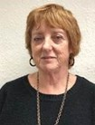

Of course, in welcoming Terry to our group, it meant that we had to say goodbye to Jane Geraghty. Jane had been the Independent Chair of BSAB for over 4 years and has actively supported and encouraged the group as well as being a regular attender of our meetings. We thank her for the dedicated support she has given the group, particularly through the Covid pandemic.

Although Jane couldn’t be at this meeting she sent her very best wishes and says that she will miss us all.



**Jon Dolby**

We were also joined at our meeting by Jon Dolby, who is a Partnership and Engagement Officer with the Stronger Communities Partnership, with special responsibilities relating to those in the Bradford District with disabilities.

The Stronger Communities Partnership Board includes a residents group called ‘The Bradford for Everyone Ambassadors (BfE)’, which is a deliberately diverse people’s advisory group. The group has a really important role to play in our district by informing the way services for communities are designed and delivered to reach the maximum number of people. Ambassadors promote the work of ‘Bradford for Everyone’ and encourage others to get involved in achieving the shared vision. More details of the ambassador scheme can be found on the [Bradford for Everyone website](https://bradfordforeveryone.co.uk/).

Jon would like to work closely with the group in future and we will be delighted to welcome him as a member.

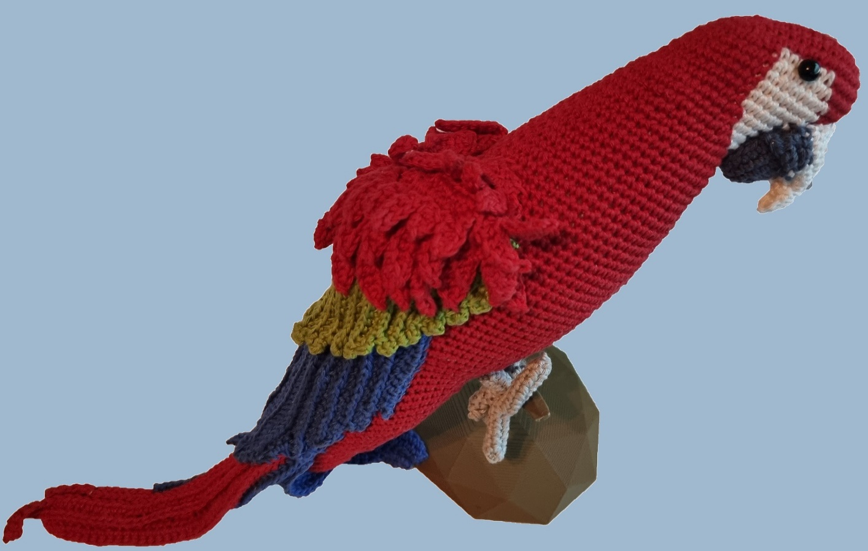**Our amazing mascot has a name!**

The fabulous parrot crocheted by Peter, our very own chair of the group, has been named ‘Poly’. This is not a misspelling of the name Polly, but a word that means ‘many’. Those who voted for this name felt that it summed up the many aspects of the work we do and the many talents that we collectively have. We will be taking Poly to any events we attend in safeguarding week and if group members would like to take Poly to any of their own events, please contact Jo.



# Safeguarding Week Stands – June 2023

Jo reported that arrangements had been made to hold a Safeguarding Voice information stand at both Bradford Broadway Shopping Centre on the 20th June and at the Airedale Shopping Centre in Bradford on the 21st June. Jo asked for volunteers form the group to come along and help – even if it was just for an hour.



**NEW CHAIRPERSON/ VICE CHAIRPERSON OF OUR GROUP!**

The time has come to elect a chairperson/ vice chairperson for our group. Please have a think about whether you wish to be considered for either of these roles and if it does interest you, please email Jo by Friday 1st September. You would need to include a statement about why you think you would be the ideal candidate and what plans you might have to promote the work of the group if you were elected.

You can apply for both roles, so that if you were to be unsuccessful in being voted by the group as the new chairperson, you could also be considered for the vice chairperson role. Candidate statements will then be circulated by email to the group and members will be asked to vote for their preferred choice.

 **TRANSPORT FORUM** Bradford People First

Bradford People First held a fantastic transport forum last year and the Campaigns Team provided us with feedback on this event. The event was really well attended and provided lots of information to everyone there, as well as giving people the opportunity to talk about issues affecting transport users with a Learning Disability. Guest speakers included Erica Ward, the transport accessibility coordinator at WYA and a representative from First Buses.

Issues identified:

* Better/ more accessible communication needed
* Anti-social behaviour should be dealt with
* Anxiety when the bus is very full/ no seats left
* Worries about missing the stop as unable to get to the buzzer on a crowded bus
* Not being able to see where you are when the bus is full, if it is dark or is steamed up because it’s raining
* Crowded buses can mean sensory overload
* Anxiety when dogs are not on leads
* Computer display systems not always working - plus difficulties reading these when a passenger has sight problems or a learning disability
* No spaces left for wheelchair users
* Drivers not willing to operate the kneeling mechanism
* Drivers not stopping
* Difficulties manoeuvring wheelchairs on buses due to railings/ crowded buses
* Taxi drivers not willing to come all the way up driveways to pick up/ drop off
* Increased taxi fares due to CAZ
* Drivers not waiting until wheelchair users are securely in position

What would help us:

* More LD awareness training during driver induction/ annual training
* Voice announcements by the driver
* To have more patience – not all disabilities are obvious.

☺ There were also positive stories including praise for a bus driver who made sure he helped passengers who needed support when the bus had broken down.

☺ First buses have also offered to bring a bus to the Mayfield Centre so that wheelchair users can practice getting on and off buses and drivers can see the problems experienced.

First Buses Website have some great cards that can be printed and used to alert the driver to any help you might need – there is even a blank one that you can insert your own information. If you don’t have access to a printer, you could screen shot the card. These could also be used in other situations. You can find details here:

<https://www.firstbus.co.uk/uploads/node_images/Extra-Help-To-Travel-journey-assistance-cards-june-20-v2.pdf>

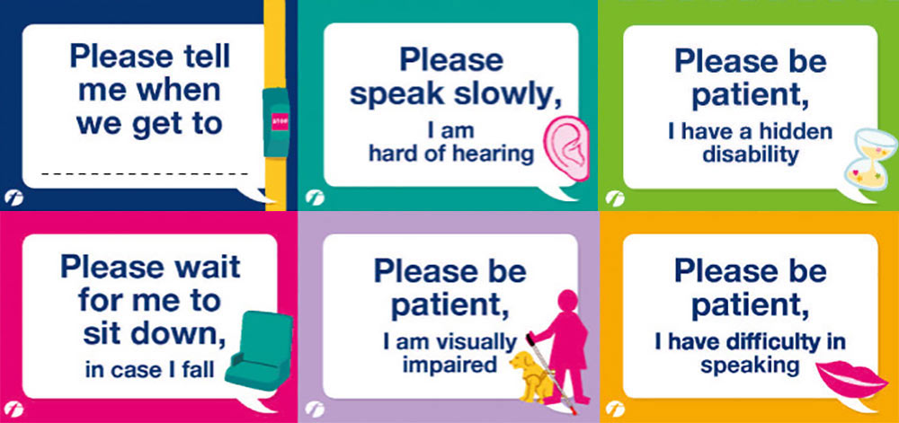

**A tip to report any issues on buses: Take a picture of the bus identity number which is on the back and front of bus (not the route number) send this with details of the bus stop/ route and time so that supervisors can speak to the driver.**

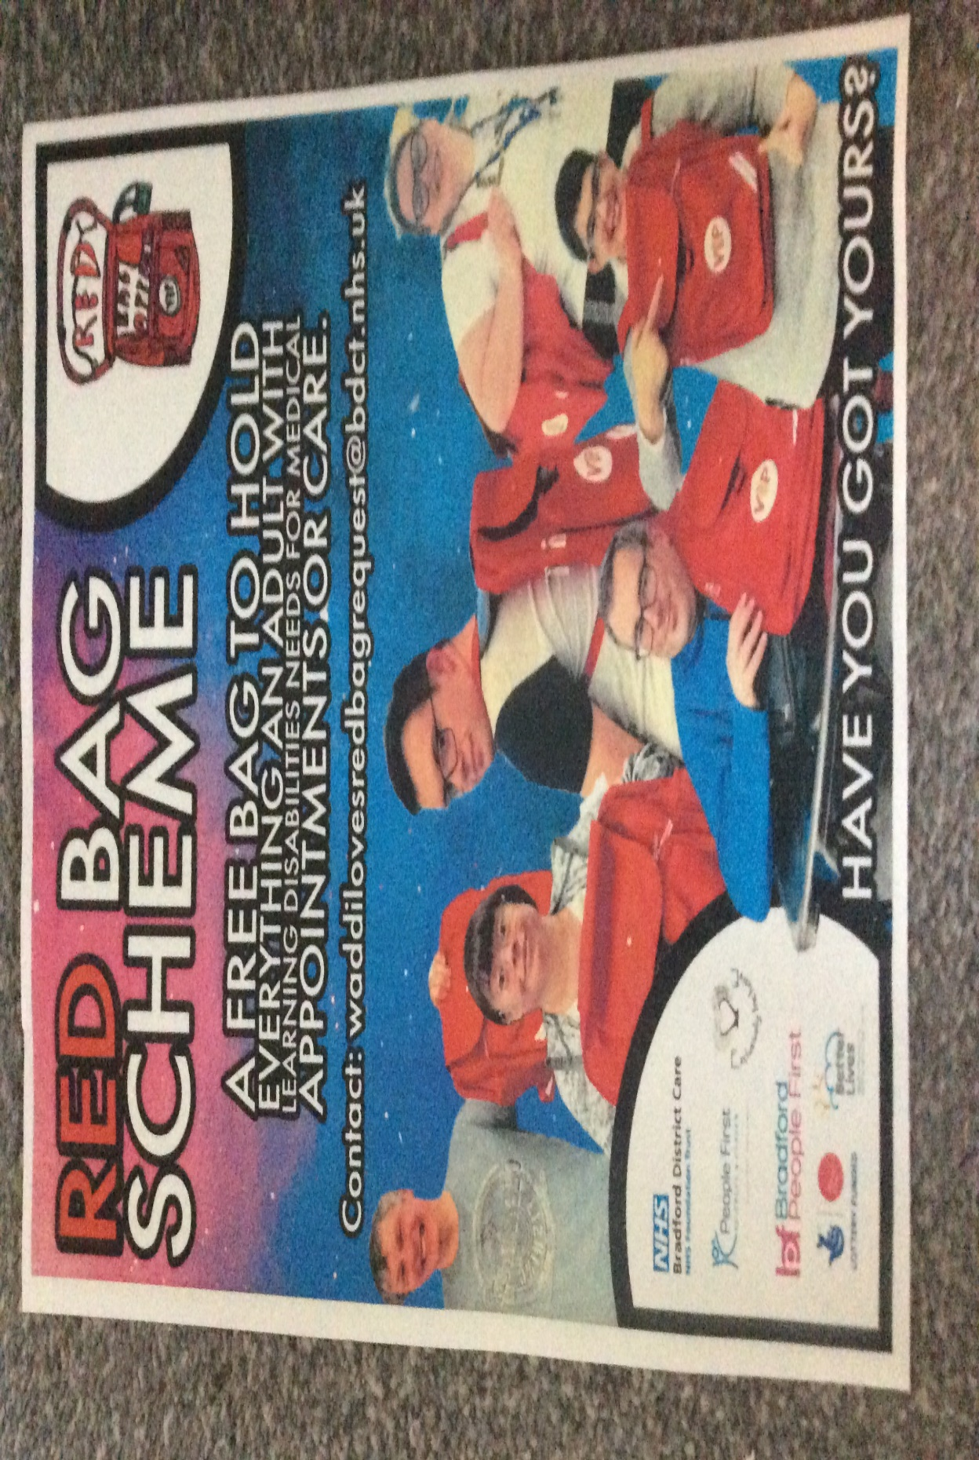

**RED BAG SCHEME**

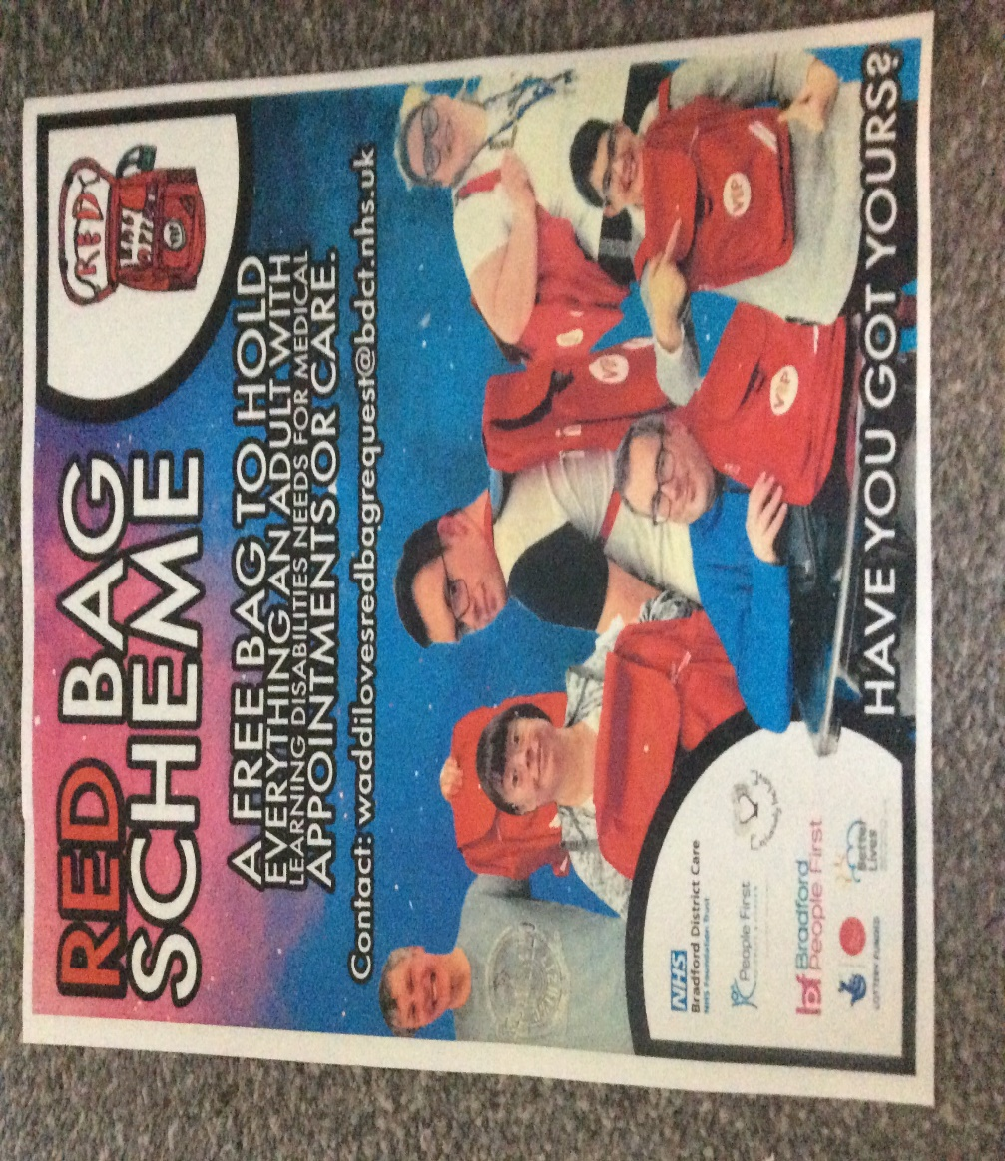

Bradford People First provided information about the Red Bag scheme which they and People First Keighley and Craven have worked on in conjunction with Waddiloves. The aim is to provide those with a learning disability with a red bag which will contain really important information about a person’s likes and dislikes as well as medical information needed. The information the bag contains will be completely individual to the owner and will be used in the event of a visit to hospital, a stay in hospital or a transfer to a care home.

It is a practical tool that keeps people’s belongings safe, as well as being a simple and effective way to share critical information with health workers from different services so that they can work effectively as a team.

For example; Paramedic and ambulance staff will be able to access information quickly from the bag, improving communication and care. Once the patient is in hospital the bag provides a single easily identifiable place to keep things that are precious to them so their details or personal items don’t get lost in transit and the bag will remain close to a person if they are admitted to hospital.

Information on who to contact to get yours is below and in the poster above – you might also be able to spot some familiar faces from People First Keighley and Craven!

Information events will be held at BRI and Airedale hospital in June

To request a bag please email: [waddilovesredbagrequest@bdct.nhs.uk](mailto:waddilovesredbagrequest@bdct.nhs.uk)

# PRIORITY SETTING

Our last newsletter gave details of the priorities that we had set as a group, which were:

1. Ensuring people understand what safeguarding is
2. Broadening membership of the safeguarding network
3. Stronger links with SAB
4. Networking opportunities
5. Access to services & ensuring people understand the role of agencies
6. Raising awareness of mental health issues

**Progress already made:**

**Priority 1** ‘**Ensuring People Understand What Safeguarding Is’ addressed by having information stands at the following:**

* Bradford Broadway Shopping Centre in Safeguarding Week
* Keighley Airedale Shopping Centre in Safeguarding Week
* Learning Zone Summer Fair
* Burley in Wharfedale Volunteer/ Charity Day
* Fresher’s Fairs at Shipley College
* Fresher’s Fair at Bradford College



**Resources have been developed and distributed as follows:**

* Business cards
* Hate and Mate Crime Leaflets
* Posters with tear off contact slips

Could you display one of our posters in your office or public space?

If so, please email:

Jo Hirst

Joanne.hirst2@bradford.gov.uk

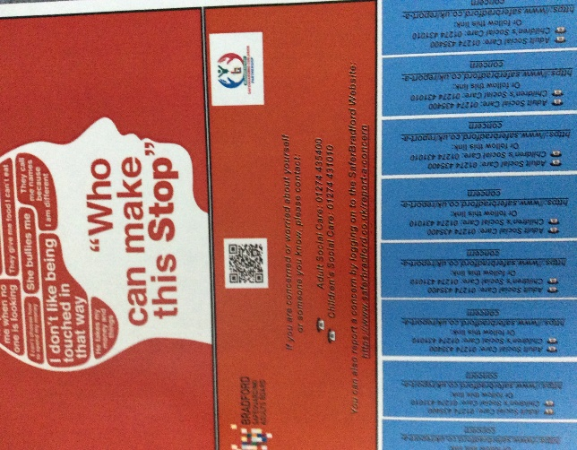

A4 size

Ideal for a notice board or to be positioned behind the doors of toilet cubicles. Slips at the bottom can be pre-cut for easy removal – or the QR code can be used to access information

**Priority 3** ‘Creating Stronger Links with BSAB’:

* Catrina/ Peter/ Gill are part of the Comms and Engagement Sub Group
* Terry wishes to make the Voice an integral part of SAB Meetings
* Involvement on Development Days

**Activities planned for October 2023 to March 2024**

**Priority 2: Broadening Membership of the Safeguarding Voice Group to include:**

* Faith groups.
* Refugees/ Asylum Seekers (or representatives). Jo to speak to Jordan A.
* Polish/ Ukrainian communities (reports of Ukrainian individuals being targeted.
* Food banks (Jo has contacts with St Johns/ Shine and Queensbury).
* To meet at different locations to allow attendance of those that live away from centre of Bradford.

**Priority 6: Raising Awareness of Mental Health Issues**

* Learning Disability is different to Mental Health issues.
* If someone is not getting help, it is easy for them to withdraw and the situation become worse (Covid had a big impact).
* Everyone’s mental health goes through changes and poor physical health can impact on mental health.
* Are issues caused by poor access to services?
* Sometimes delays are caused by over complicated admin processes.
* Mental Health support – ensuring people know where and when to seek help is crucial.
* Voice Group to attend events to raise awareness of Mental Health issues.
* To invite key note speakers to Voice Group meetings.
* Find out which organisations support learning disability AND Mental Health (e.g. Oliver McGowan Training Programme).
* What organisations are out there to support Mental Health issues?
* Check out views of access/ services – maybe a piece of work with Healthwatch?
* Drugs and alcohol abuse can prevent people seeking help – particularly coupled with a learning disability.

Severe mental health issues such as Bi-polar and Schizophrenia can sometimes reduce life expectancy by 20/ 30 years and there is a great need to raise awareness of self-care. There is a Mental Health Awareness Day on the 10th October and it was agreed that we should aim towards this date to produce literature or hold an event? We will collate information on which organisations support those with a Learning Disability AND Mental Health issues - Jo will also scope key note speakers to come and speak to the group**.** There is still more work to be done to come up with an implementation plan and this will be discussed at the next meeting. We also need to look at timescales and Data intelligence to inform the reach of our work. If you have any ideas as to how we can implement this/ advance work on our priorities please email Jo Hirst: [joanne.hirst2@bradford.gov.uk](mailto:joanne.hirst2@bradford.gov.uk)

**OTHER NEWS!**

We were joined for the first time by Jayne who has replaced Samina working with the campaigns team at Bradford People First. We pass on our thanks and best wishes to Samina and really look forward to working with Jayne in the future.

Bradford People First

i

**WELCOME**

We were also delighted to welcome Andrew Marshall, who is the principal social worker at the Marie Curie Hospital in Bradford. Andrew spoke about the challenging but rewarding work he does with Marie Curie and he is looking forward to being part of the group.





People First, Keighley and Craven were unable to join us for this meeting. As usual, they have been very busy and have recently worked on a really exciting project to highlight the risk of domestic violence and sexual abuse towards individuals with a Learning Disability.

The project came about as a result of a meeting between Lizzie from the Domestic Abuse Team, Catrina and Jo and involved members of PFKC being film stars for the day. It was such an exciting day working with a professional film director and everyone worked so hard to remember their lines.

The film we made will be available soon and we can’t wait to show you!



# SUMMARY

* The Group completed lots of work within the meeting and welcomed the new Independent Chair of BSAB
* We continue to welcome new members to the group, making really important links within our district in order to hear the voice of under-represented groups.
* We continue to seek feedback and ideas from the group to ensure that our voice is considered within BSAB planning and development work.

# We had feedback on Bradford People First’s Transport Forum and learnt about the Red Bag Scheme

# make decisions - Clip Art LibraryTHE NEXT MONTHS – OUR FUTURE PLANS

* We will spend time at the next meeting looking at Priority 2 so that we have a firm plan for Mental Health Awareness Day in October.
* To complete the activity ‘what makes a good friend’ – time was not on our side at this meeting as we had so much work to do!
* Investigate additional training on social media offered by ‘People Can’.
* Additional group work/ circulation of information on keeping people safe, covering:
* Avoiding people preying on the isolated and vulnerable
* Podcasts about safeguarding the vulnerable and disabled
* Contact the Mobility Planning Group to invite them to a future meeting

**Safeguarding Voice would like to invite you to our meetings. Come and share how you are working across Bradford to help keep people safe – share with us your good practice! Do you want a genuine service user voice......well we are here to help! For more details email** [**BSAB@bradford.gov.uk**](mailto:BSAB@bradford.gov.uk)

**Do you know of anyone who might benefit from joining our group if so get in touch with Helen or Jo at** [**BSAB@bradford.gov.uk**](mailto:BSAB@bradford.gov.uk)