Safeguarding Children Narrated Presentations

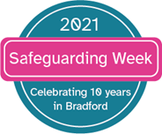

These 5 safeguarding children presentations have been developed and narrated by Dr Kate Ward.
The target audience are for professionals who work directly with children.
The approximate running times of each package are between 42 minutes -1hr 10 minutes.
The choice of how many and which presentations you view are entirely for you to choose, and can be used as part of both your own professional development and safeguarding children training updates.

To access these presentations, click on any of the links below:

Burns
https://youtu.be/qnwCNisPEdE

Bruises and Soft Tissue Injuries
https://youtu.be/iLU1lKI4zHM

Abusive Head Trauma
https://youtu.be/Mwg-wfC7JOw

Abusive Abdominal and visceral injuries:
https://youtu.be/BWnO1kFifnw

Fractures in Children
https://youtu.be/If5ZkrpMzIc

