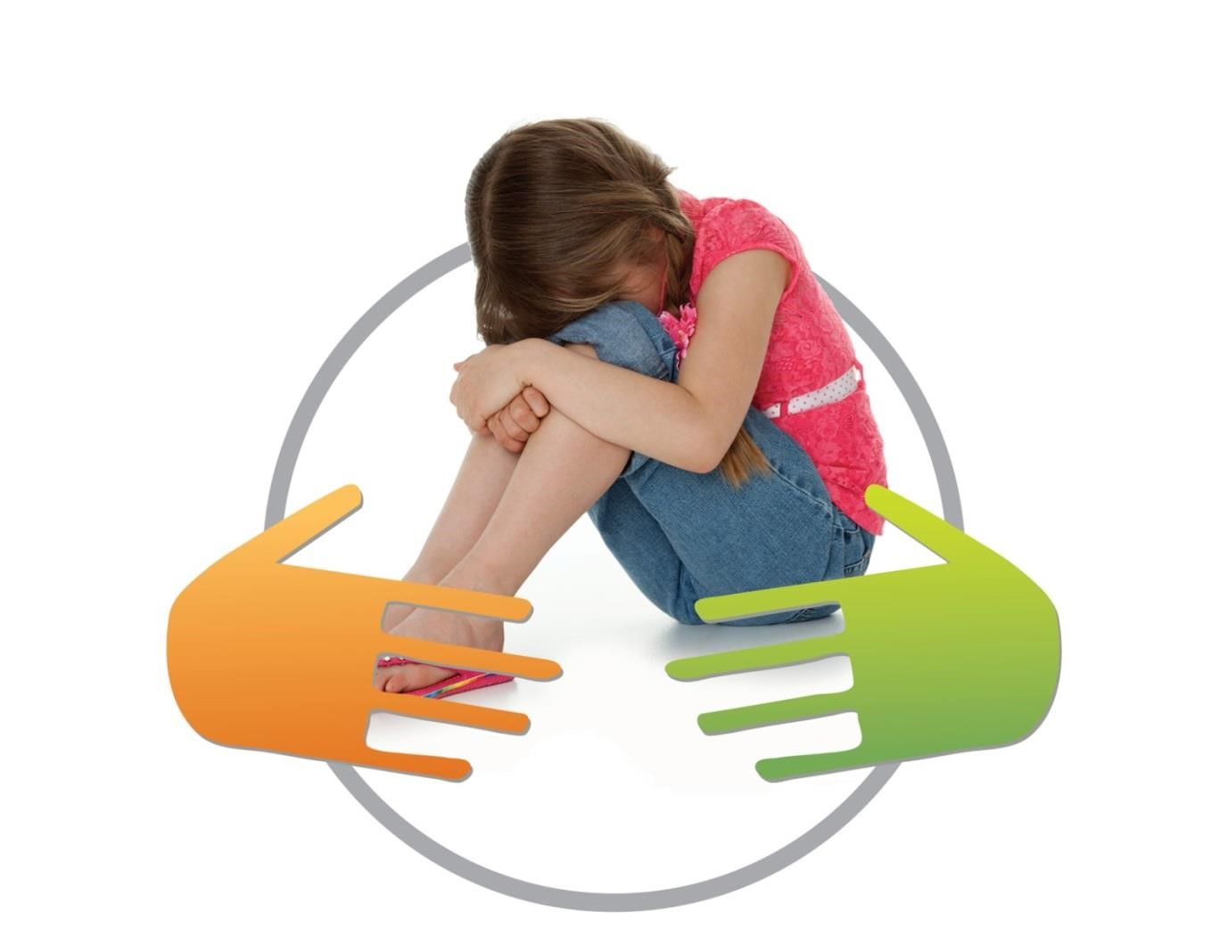
Bradford Neglect Toolkit

Amended and Updated – July 2022
Next Review Date – July 2024

Contents:
- Definition of Neglect Page 3
- Risk Factors Page 3
- Purpose of this tool Page 4
- Flow Chart Page 5
- Possible Indicators of Neglect Page 6
- Using the toolkit Page 7
- Identifying signs of neglect Page 9
- Emotional and behaviour Page 10
- Environmental Factors Page 12
- Health/Physical Care Page 14
- Parenting Page 16
- Education Page 18
- Feeding and Eating Page 19
- What Happens Next? Page 20

Definition of Neglect:
Neglect is defined in Working Together to Safeguard Children (HM Government 2018; page 104) as;
“The persistent failure to meet a child’s basic physical and/or psychological needs, likely to result in the serious impairment of the child’s health and development. Neglect may occur during pregnancy as a result of maternal substance abuse. Once a child is born, neglect may involve a parent or carer failing to:
- Provide adequate food, clothing and shelter (including exclusion from home or abandonment)
- Protect children from physical and emotional harm or danger
- Ensure adequate supervision including the use of inadequate care givers
- Ensure access to appropriate medical care or treatment
- Neglect of, or unresponsiveness to, a child’s basic emotional needs“
The British Society of Paediatric Dentistry (BSPD) also published a policy document in 2009 on dental neglect which defined dental neglect as ‘the persistent failure to meet a child’s basic oral health needs, likely to result in the serious impairment of a child’s oral or general health or development’ (Harris JC, Balmer RC, Sidebotham PD. British Society of Paediatric Dentistry: a policy document on dental neglect in children. Int J Paediatr Dent. 2009 May 14).

Neglect can cause serious, long-term harm to a child. If a baby or young child suffers neglect, this can have a big impact on how their brain develops with life-long consequences for their learning, behaviour and mental and physical health. In the most severe cases this can be fatal (NSPCC 2016).
Neglect also has a negative impact on older children and teenagers. Some of the long-term effects of chronic neglect include:
- Mental health problems including depression, anxiety, mood swings and post-traumatic stress disorder
- Risky behaviour such as breaking the law or abusing drugs or alcohol
- Difficulties forming or maintaining healthy relationships
- Generally poorer performance at school than children who do not suffer neglect.
(NSPCC and Cardiff University, 2014 4a, b).
Risk factors:
Any child can suffer neglect, but some are more at risk such as children who:
- are seeking asylum
- are born prematurely
- have a disability
- have complex health needs
- live with a parent who has problems with drugs or alcohol
- parents who suffer from mental health problems
- living in a household where there is domestic abuse
- living in poverty, in unsuitable housing or in a deprived area
- having parents who were abused or neglected themselves

Neglect happens in many contexts, and there isn't usually one single cause. Just because one or more of these factors is present, it doesn't mean a child will be neglected; but we do know that having one or more of these factors present increases the risk of neglect (www.nspcc.org.uk). In some cases support can be provided by universal services to assist with debt, budgeting, housing and so on, and will mean the ‘at risk’ children in this setting will not necessarily be subjected to neglect.

Purpose of this tool:
To guide front line practitioners to:
- Identify the signs of neglect at an early stage
- Recognise the need for further action
- Identify which agency/organisation/professional will carry out further assessments or intervention as required.

Flow Chart:
Evidence of or concerns about the existence of neglect

Contact CSC professionals contact and advice line (01274 433999)
Are there immediate safeguarding concerns?
Yes

No

Use neglect screening tool to further identify signs of neglect, give details, and consider the need for further action

Either seek advice from your safeguarding supervisor or Contact CSC professionals contact and advice line (01274 433999)
Has the toolkit identified any concerns of significant harm?
Yes
No
Can your service provide any additional support needed?
Continue with a single agency response and consider signposting to universal services
Yes

No
Contact CSC professionals contact and advice line (01274 433999) indicating Early Help services are required.

Continue to Support the family and reassess needs as required

Possible Indicators of Neglect:
Neglect can be difficult to identify. Isolated signs may not mean that a child is suffering neglect, but multiple and persistent signs over time could indicate a serious problem. Some of the signs a child may be experiencing neglect include (this is not an exhaustive list):
- Appearing dirty, smelly or hungry
- Having clothes which are unwashed or inadequate for the weather conditions
- Being left alone or unsupervised
- Failing to thrive or having untreated injuries, health or dental problems
- Not being brought to medical appointments
- Having poor language, communication or social skills for their stage of development
- Living in a home that is very dirty and unsafe, perhaps with evidence of substance misuse or violence
- Taking on the role of carer for other family members
- Neglect of medical /dental/health issues including over or underweight
- Reluctance to return home
- Frequent unexplained minor injuries
- Emotional Withdrawal
- Children who frequently go missing
- Lack of age appropriate stimulation and supervision

Examples of neglect presenting in the dental setting include (Balmer et al, 2010):

- Child in pain presents with extensive, untreated oral disease
- Late presentation of obvious severe oral pathology
- Attends emergency toothache appointments only and is not brought to follow-up appointments
- Severe dental trauma when inadequately supervised
- History of multiple repeat dental general anesthetic
- Essential antibiotics for dental abscess not administered

Of note, there is no threshold level of dental decay beyond which a diagnosis of dental neglect can be made. The more important and key factors when considering dental neglect are:
- the response of the carer to the presence of oral disease
- the carers acceptance (or otherwise) of taking-up any acceptable dental care that is offered for their child
- the impact dental disease has had on the child.

Using the Toolkit.
The toolkit should be used in conjunction with:
- The Bradford Continuum of Need and Risk document
Continuum of Need Document
- Bradford’s Neglect Strategy–
Bradford Neglect Strategy

The toolkit is a guide only and it should not replace professional judgment or be the deciding factor in decision making. Practitioners should seek advice from their line manager if they are worried or unsure how to proceed.

The toolkit is for practitioners to use in order to support them in identifying factors which may indicate that a child or young person is being neglected. The toolkit will support the practitioner to assess any potential harm to a child or young person and give them the appropriate tools to support the identification of neglect of a child or young person. It is important that the focus remains on the child or young person with the voice of the child always sought and responded to, as to what they think of their care and living conditions, their health and wellbeing and their development.

The application of the toolkit should include having an honest and respectful conversation with the parent /carer of the child about the worries around neglect. The toolkit should be used with due care, diligence and sensitivity. It should be completed in collaboration with the family and used as a guide to help ensure that the needs of the children and young people within the home are being met and can also be used with families to assist their understanding of neglect.

The toolkit should be used by practitioners to consider what they have observed, enable reflection on their observations and assist their decision making about what needs to happen. Practitioners should be appropriately probing in assessing the circumstances and should be curious and questioning about information provided to them by families. It can be tempting to concentrate on the present situation or see a change (such as a new worker) as a ‘fresh start’ but it is important to see current events in the context of a full history of safeguarding issues including how a family has previously responded to support.

The tool is intended for front line practitioners within partner agencies as a means to quickly identify areas of concern which may indicate a child/young person is being neglected. It is intended to complement existing tools e.g. Early Help assessment, Social Work assessment, and/or other agency specific screening/assessment tools and should be used accordingly. The tool is designed to be applicable to all ages of children and should help you identify neglect and associated factors across all age ranges.
In order to complete this tool it is essential that you are able to evidence the reasons why you have highlighted concerns for any of the factors indicated. Only complete the parts of the tool you are certain about. If you are unsure about completing the assessment, seek appropriate help within your organisation. It is essential that where you have highlighted areas of the assessment where you are very concerned or sometimes concerned that you provide further information to evidence these concerns.
A note on cumulative harm: Neglect is different from other forms of abuse because it isn’t necessarily a single incident or crisis that brings attention to the family but rather it is more likely to be repeated, persistent neglectful behaviour that causes damage over time;
“The unremitting daily impact of these experiences on the child can be profound and exponential, and diminish a child’s sense of safety, stability and wellbeing.” (Bromfield and Miller 2007)
“Cumulative harm can overwhelm even the most resilient child; attention should be given to the complexity of the child’s experience.” (Bromfield and Miller 2007).

An important part of detecting and managing neglect is the persistence of concerns/issues despite input, support and attempts to understand why the carers are unable to provide the care in question. To show neglect the professional needs to demonstrate potential “significant harm” and that the carer is responsible, despite support. Careful recording of support and advice given is important. Referrals need to include detailed information about consequences of neglect e.g. dental neglect likely to result in serious impairment of the child’s oral/general health and/or development due to dental caries leading to pain/ infection/inability to sleep or eat as normal and/or loss of teeth.
When considering neglect issues for children due consideration should be given to the health and medical/dental issues displayed in the case including such issues as obesity, poor oral health, lack of immunisations and the support of parents and carers in ensuring they attend medical/dental appointments. These are covered in the tool below and practitioners should ensure these are adequately reflected in their considerations. These are a reflection of the psychosocial aspects of parenting and cannot be managed by health workers alone

Name(s): | Parent(s)/Carer(s):
DOB or EDD: | Contact telephone number:
Address: | Other members of the household:
Have you discussed your concerns with parent(s)/carer(s)? Yes/No
What was the outcome of this discussion? Have they given their consent? What were their views?

Does the child have any additional needs? Yes/No

If YES please give details:

Has the child been spoken to about what they think of
their care and living conditions, their health and wellbeing
and their development? Yes/No

If NO please explain why, if YES please elaborate:
(For non-verbal children consider observations of the child – emotional and physical presentation and relationship with care giver)

Name of practitioner or agency: | Date form completed:
Identifying Signs of Neglect

s):

Use each child’s initials if there are separate siblings that this document relates to and include a key if necessary.
Category: Emotional and Behaviour |  |  | Very concerned |  | Sometimes |  |  | Not concerned
Relationships with peers/support networks are poor
Child feels or is excluded by family
Child is excessively clingy, fearful, withdrawn, anxious, avoidant, socially unresponsive or unusually quiet for his or her age
High criticism, low warmth from parent/carer
Care giver in the family appears to resent the child
Child seeks physical comfort from a stranger/professional
Under-stimulation evident
Prolonged lack of appropriate supervision
Lack of online supervision, exposed to inappropriate films, websites, games or materials
Child appears not to want to go home
Episodes of missing or running away
Child has inappropriate carer responsibilities for other family members
Parent/carer complicit in child having inappropriate relationships with other adults.
Emotional and Behaviour - Evidence: Please use this space to record any strengths or concerns and detail what’s been tried (Including parent/carer view).
What are we worried about? |  | What’s working well? |  |  |  | What needs to happen?
Safety Scale – On a scale of 0 -10 where 0 is severe impact and 10 is no impact, where would we rate the answers in this category as having an impact on the child(ren). Please identify separate children using initials if necessary.

0 10

Use each child’s initials if there are separate siblings that this document relates to and include a key if necessary.

Category: Environmental Factors |  |  | Very concerned |  | Sometimes |  |  | Not concerned
Unsafe or unhygienic home environment
Not enough or no bedding/furniture
Social isolation or poverty
Human and/or animal excrement
Vulnerable to injury from animals due lack of supervision
Little or no evidence of food being provided
Poor housing conditions e.g. overcrowding, poor standard of repair
Adults or young people in the home that agencies have been previously unaware of whose risk is unknown
Environmental Factors - Evidence: Please use this space to record any strengths or concerns and detail what’s been tried (Including parent/carer view).
What are we worried about? |  | What’s working well? |  |  |  | What needs to happen?
Safety Scale – On a scale of 0 -10 where 0 is severe impact and 10 is no impact, where would we rate the answers in this category as having an impact on the child(ren). Please identify separate children using initials if necessary.

0 10
Use each child’s initials if there are separate siblings that this document relates to and include a key if necessary.

Category: Health/physical care |  |  | Very concerned |  | Sometimes |  |  | Not concerned
Frequent attendance at A&E and/or hospital admission
Poor nutrition including poor weight gain/ /obesity/ with lack of engagement with services in relation to their weight management and health problems related
Other co-existing health problems associated with obesity e.g., sleep apnoea, joint problems, weight related injuries, incontinence, diabetes, skin conditions liver disease
Child’s outcomes are compromised by poor nutrition, e.g. social activities/interaction with peers/educational attainment
Untreated or persistent head lice or other infestation
Medical/dental neglect: lack of engagement e.g. Refusing help/services/not following advice given/not accessing appropriate medical/dental advice or care
Poor personal hygiene of child including poor oral hygiene habits
Substance abuse/misuse by child/adult/household member
Child not brought to appointments/
Not suitably dressed for time of year/clothes are not clean/do not fit/not enough clothes
Not registered with a GP
Child in pain presents with extensive, untreated oral disease
Late presentation of obvious severe oral pathology
Dental trauma when inadequately supervised

Red/mottled skin, particularly hands and feet, seen in the winter due to cold/hypothermia
Not up to date with immunisations (and not due to an informed decision not to immunise)

Health/Physical Care - Evidence: Please use this space to record any strengths or concerns and detail what’s been tried (Including parent/carer view).
What are we worried about? |  | What’s working well? |  |  |  | What needs to happen?
Safety Scale – On a scale of 0 -10 where 0 is severe impact and 10 is no impact, where would we rate the answers in this category as having an impact on the child(ren). Please identify separate children using initials if necessary.

0 10

Use each child’s initials if there are separate siblings that this document relates to and include a key if necessary.

Category: Parenting |  |  | Very concerned |  | Sometimes |  |  | Not concerned
Poor/inappropriate family support or support network
Lack of boundaries
Fail to give child suitable boundaries for behaviour
Substance misuse/abuse that impacts on parenting
Mental health or learning disability that impacts on parenting
Domestic abuse
Parent or carer giving the appearance of co-operating with agencies to avoid raising suspicions, to put to rest professional concerns and ultimately to diffuse professional intervention.

Parents/Carers manipulate information shared with multiple agencies resulting in inconsistencies between professionals (in a deliberate attempt to hide or misinform for personal gain)

Aggressive or threatening behaviour towards professionals
Leaving children with inappropriate carers/babysitters/left home alone
Unrealistic expectations of child for their age
Incidents that suggest lack of supervision such as sunburn or other burn, ingestion of a harmful substance(s), near drowning, road-traffic accident or being bitten by an animal

Parenting - Evidence: Please use this space to record any strengths or concerns and detail what’s been tried (Including parent/carer view).
What are we worried about? |  | What’s working well? |  |  |  | What needs to happen?
Safety Scale – On a scale of 0 -10 where 0 is severe impact and 10 is no impact, where would we rate the answers in this category as having an impact on the child(ren). Please identify separate children using initials if necessary.

0 10
Use each child’s initials if there are separate siblings that this document relates to and include a key if necessary.

Category: Education |  |  | Very concerned |  | Sometimes |  |  | Not concerned
Non-attendance/poor attendance at education setting (below 80%)
Not on a school roll and no evidence provided of suitable home education’
Not achieving as expected for age directly linked to neglect or parenting
Socially withdrawn
Noticeable / worrying concerns around lack of uniform / equipment for stage of education or training
Lack of / deteriorating parental/carer engagement with education setting
Often tired / lethargic due to little or no sleep.
Unexplained extremes of behaviour (often sudden or without warning)
Emotionally withdrawn in setting due to not having emotional needs met in the home
Education – Evidence: Please use this space to record any strengths or concerns and detail what’s been tried (Including parent/carer view).
What are we worried about? |  | What’s working well? |  |  |  | What needs to happen?
Safety Scale – On a scale of 0 -10 where 0 is severe impact and 10 is no impact, where would we rate the answers in this category as having an impact on the child(ren). Please identify separate children using initials if necessary.

0 10

Use each child’s initials if there are separate siblings that this document relates to and include a key if necessary.

Category: Feeding and Eating |  |  | Very concerned |  | Sometimes |  |  | Not concerned
Abnormal appetite/ravenous at nursery/school
Little or no evidence of food being provided
Stealing/scavenging food
Does not have breakfast/misses regular meals
Poor quality diet little nutritious food, high fat, / sugar
Child is under / overfed
Carers do not acknowledge the under or over weight concerns
Feeding and Eating - Evidence: Please use this space to record any strengths or concerns and detail what’s been tried (Including parent/carer view).
What are we worried about? |  | What’s working well? |  |  |  | What needs to happen?
Safety Scale – On a scale of 0 -10 where 0 is severe impact and 10 is no impact, where would we rate the answers in this category as having an impact on the child(ren). Please identify separate children using initials if necessary.

0 10

Onward referral? What needs to happen next?
Identified Concerns | Safety Plan | Desired Outcomes
Give a summary in this section based on findings throughout the document:

Have you discussed concerns with your line manager or a safeguarding lead? Yes No
Do you need to contact the CSC advice line? Yes No
If no, what further action is being taken?

